CryptoQNet Leveraging Quantum Computing for Enhanced Cryptocurrency Market Analysis
A project report Submitted in partial fulfillment of the requirements for the Award of the degree of

Bachelor of Technology
in

COMPUTER SCIENCE AND ENGINEERING

By

Name | (Reg.No)
Under the Esteemed Guidance of
Internal Guide | HeadoftheDepartment
Name | Name
Asst.Professor | Professor&HOD

CERTIFICATE

This is to certify that the Project Report entitled “CryptoQNet Leveraging Quantum Computing for Enhanced Cryptocurrency Market Analysis”, that is being submitted byName(Reg.no),in partial fulfillment for the award of the Degree of Bachelor of Technology in Computer Science and Engineering, Pragati Engineering College is a record of Bonafide work carried out by them.

Internal Guide | Headof theDepartment
name | name
Asst.Professor,CSEDepartment | Professor&HOD
ExternalExaminer

ACKNOWLEDGEMENTS

Entrusting into Project work of “CryptoQNet Leveraging Quantum Computing for Enhanced Cryptocurrency Market Analysis enabled us to express our special thanks to Name, Chairman of (College name) Engineering College,(place name).

I am extremely thankful to our honorable Principal Name, who has shown keen interest in us and encouraged us by providing all the facilities to complete our project successfully.

I owe our gratitude to our beloved Head of the Department of CSE, Name for assisting us in completing our project work.

I express our sincere thanks to our guide Name who has been a source of inspiration for us through out our project and for her valuable advices in making our project a success.

I wish to express my sincere thanks to all teaching and non-teaching staff of Computer Science and Engineering Department.

Name (Reg.No)
ABSTRACT

Cryptocurrency markets are highly dynamic and volatile, making accurate price prediction and market analysis a challenging task. Traditional statistical methods and classical machine learning models often fail to effectively capture complex nonlinear patterns and sudden fluctuations present in cryptocurrency time-series data. Although deep learning models such as Long Short-Term Memory (LSTM) and Gated Recurrent Units (GRU) have shown improved performance, they still suffer from high computational cost and limited scalability.

This project presents CryptoQNet, a quantum computing–based framework designed to enhance cryptocurrency market analysis and prediction accuracy. The proposed system integrates quantum feature mapping, variational quantum circuits, and a quantum recurrent neural network structure to efficiently model complex temporal and nonlinear relationships in market data. Historical cryptocurrency price data is preprocessed and transformed into quantum states, enabling improved representation of high-dimensional features.

The performance of the proposed model is evaluated using standard metrics such as Mean Absolute Error (MAE), Root Mean Squared Error (RMSE), and Mean Absolute Percentage Error (MAPE). Experimental results demonstrate that CryptoQNet outperforms classical deep learning models in terms of prediction accuracy and volatility handling. The findings highlight the potential of quantum machine learning as a promising approach for future financial market analysis and intelligent decision-making systems.

TABLE OF CONTENTS

ACKNOWLEDGEMENTS |  | iii
ABSTRACT |  | iv
LISTOFFIGURES |  | vi
Chapter1. | Introduction | 1
Chapter2. | LiteratureSurvey | 3
Chapter3. | SystemAnalysis | 6
3.1 | Existing System | 7
3.2 | ProposedSystem | 8
Chapter4. | SystemDesign | 9
4.1 | SystemArchitecture | 10
4.2 | UMLRepresentation | 11
Chapter5. | SystemImplementation | 16
5.1 | Modules | 17
5.2 | SystemRequirements | 19
Chapter6. | SystemTesting | 43
6.1 | TypesofTesting | 44
6.2 | Teststrategyand approach | 45
Chapter7. | ScreenShots | 47
Chapter8. | ConclusionandFuturework | 54
 | Reference | 56
APPENDIX-A | SourceCode | 59

INTRODUCTION

1. INTRODUCTION

Cryptocurrency markets have gained significant attention in recent years due to their rapid growth and high investment potential. However, these markets are highly volatile, nonlinear, and complex in nature. Prices of cryptocurrencies such as Bitcoin and Ethereum change frequently due to factors like trading volume, market sentiment, and global economic conditions. Because of this complexity, traditional statistical methods and classical machine learning models often struggle to provide accurate market analysis and reliable price predictions

With the advancement of artificial intelligence, deep learning models such as Long Short-Term Memory (LSTM) and Gated Recurrent Units (GRU) have been widely used for time-series forecasting in financial markets. Although these models improve prediction accuracy to some extent, they still face limitations when handling high-dimensional data, extreme volatility, and long-term dependencies in cryptocurrency markets. This creates a need for more powerful computational approaches that can capture complex market patterns efficiently

Quantum computing has emerged as a promising technology capable of solving complex problems that are difficult for classical computers. By utilizing quantum principles such as superposition and entanglement, quantum computing can process large-scale and multidimensional data more efficiently. In the context of financial markets, quantum machine learning techniques have shown strong potential for improving prediction accuracy, optimization, and interpretability

In this context, the project CryptoQNet: Leveraging Quantum Computing for Enhanced Cryptocurrency Market Analysis introduces a novel quantum computing-based framework for analyzing cryptocurrency price trends and market volatility. CryptoQNet integrates advanced quantum components such as Quantum Feature Maps, Variational Quantum Circuits, and Quantum Recurrent Neural Networks to enhance data representation and forecasting performance. The proposed model is designed to overcome the limitations of classical deep learning models by capturing complex temporal and nonlinear relationships present in cryptocurrency markets

The primary goal of CryptoQNet is to improve prediction accuracy for cryptocurrency prices and volatility while maintaining interpretability and computational efficiency. Experimental results demonstrate that CryptoQNet outperforms traditional models like LSTM and GRU in terms of error metrics such as Mean Absolute Error (MAE), Root Mean Squared Error (RMSE), and Mean Absolute Percentage Error (MAPE). This highlights the potential of quantum computing as a transformative tool for future financial market analysis and decision-making systems

LITERATURESURVEY

LITERATURE SURVEY

Cryptocurrency market analysis has been widely studied due to the highly volatile and unpredictable nature of digital assets. Early research mainly focused on traditional statistical techniques such as Autoregressive Integrated Moving Average (ARIMA) and Generalized Autoregressive Conditional Heteroskedasticity (GARCH) models for price forecasting and volatility analysis. Although these methods provided basic insights, they were limited in handling nonlinear patterns and complex dependencies present in cryptocurrency time-series data
With the growth of machine learning, researchers began applying algorithms such as Support Vector Machines (SVM), Random Forests, and Linear Regression models to predict cryptocurrency prices. These models showed better performance compared to traditional statistical approaches. However, they still struggled with high-dimensional data, rapid market fluctuations, and long-term temporal dependencies, which reduced their prediction reliability in real-world trading environments
Deep learning models, especially Recurrent Neural Networks (RNNs), Long Short-Term Memory (LSTM), and Gated Recurrent Units (GRU), became popular for cryptocurrency forecasting due to their ability to learn sequential patterns. Several studies demonstrated that LSTM and GRU models outperform classical machine learning techniques in terms of prediction accuracy and robustness. Despite these improvements, deep learning models require large computational resources and often fail to fully capture extreme volatility and complex nonlinear market behavior
Recent research has explored hybrid models that combine deep learning with optimization techniques and feature engineering to enhance prediction performance. Attention mechanisms, ensemble learning, and sentiment analysis using social media data have also been integrated into forecasting frameworks. While these approaches improved accuracy, they increased model complexity and reduced interpretability, making them less suitable for practical financial decision-making
Quantum computing has recently emerged as a new research direction in financial market analysis. Studies on quantum machine learning highlight its ability to process large-scale and complex datasets more efficiently than classical methods. Quantum Neural Networks (QNNs), Variational Quantum Circuits (VQC), and Quantum Feature Maps have been proposed for classification and time-series forecasting tasks. Initial results indicate that quantum-based models can capture complex nonlinear relationships with fewer parameters compared to classical deep learning models

In the context of cryptocurrency markets, limited but growing research suggests that quantum-enhanced models can outperform classical LSTM and GRU models in terms of prediction accuracy and volatility estimation. The CryptoQNet framework builds upon these studies by integrating quantum recurrent structures and variational circuits to enhance feature representation and forecasting performance. This approach addresses key limitations identified in previous literature, such as high computational cost, poor interpretability, and reduced performance under extreme market volatility

Existing System

The existing cryptocurrency market analysis systems mainly rely on classical statistical models and traditional machine learning techniques. Commonly used methods include statistical approaches such as ARIMA and GARCH for time-series forecasting, which analyze past price data to predict future trends. These models are easy to implement but are mainly suitable for linear and stable datasets.

With the advancement of artificial intelligence, classical machine learning models such as Support Vector Machines (SVM), Random Forests, and Linear Regression have been applied to cryptocurrency price prediction. These models improve prediction accuracy compared to statistical methods by learning patterns from historical data. However, their performance depends heavily on feature selection and data preprocessing.

Deep learning-based systems, especially Recurrent Neural Networks (RNNs), Long Short-Term Memory (LSTM), and Gated Recurrent Units (GRU), are widely used in current cryptocurrency forecasting systems. These models can capture temporal dependencies and nonlinear patterns in time-series data. Many existing systems use LSTM or GRU models to analyze price trends, volatility, and trading signals using large historical datasets.

Despite these advancements, existing systems are fully dependent on classical computing architectures. They require high computational resources, large training time, and extensive hyperparameter tuning. As cryptocurrency markets continue to grow in complexity and data volume, the limitations of classical systems become more evident.

Disadvantages of the Existing System

High Market Volatility Handling Limitation
Existing models struggle to accurately predict sudden price fluctuations and extreme volatility, which are common in cryptocurrency markets.
Limited Nonlinear Pattern Recognition
Traditional statistical and machine learning models are not effective in capturing complex nonlinear relationships present in market data.
High Computational Cost
Deep learning models such as LSTM and GRU require large computational power, long training time, and high memory usage.
Poor Long-Term Dependency Learning
Even advanced deep learning models may fail to efficiently learn long-term dependencies in highly dynamic and noisy time-series data.
Scalability Issues
As the number of cryptocurrencies and features increases, existing systems face difficulties in scaling efficiently.
Low Interpretability
Many deep learning-based systems act as black boxes, making it difficult to understand or explain prediction decisions.
Dependence on Classical Computing
Classical systems are limited by hardware constraints and cannot efficiently process very high-dimensional financial data.

Proposed System

The proposed system, CryptoQNet, introduces a quantum computing–based framework for enhanced cryptocurrency market analysis and prediction. Unlike existing systems that rely only on classical computing and deep learning models, CryptoQNet integrates quantum machine learning techniques with time-series forecasting models to improve prediction accuracy and efficiency.

The system uses Quantum Feature Maps to transform classical cryptocurrency market data into quantum states. This transformation allows the model to represent complex and high-dimensional data more effectively. A Variational Quantum Circuit (VQC) is then applied to learn nonlinear patterns and interactions present in the market data.

To handle sequential and temporal dependencies, the proposed system employs a Quantum Recurrent Neural Network (QRNN) structure. This quantum-enhanced recurrent model is designed to capture long-term dependencies and sudden market fluctuations more efficiently than classical LSTM and GRU models. The system is trained and evaluated using historical cryptocurrency price data and performance is measured using metrics such as MAE, RMSE, and MAPE.

By combining quantum computing principles with deep learning concepts, CryptoQNet aims to overcome the limitations of classical systems and provide a more accurate, scalable, and interpretable solution for cryptocurrency market analysis.

Advantages of Proposed System

Improved Prediction Accuracy
Quantum feature representation helps capture complex and nonlinear market patterns, leading to better forecasting performance.

Efficient Handling of High-Dimensional Data
Quantum computing enables efficient processing of large and complex datasets with fewer parameters.

Better Volatility Modeling
The proposed system effectively handles sudden price changes and extreme volatility common in cryptocurrency markets.

Enhanced Long-Term Dependency Learning
The quantum recurrent structure improves learning of long-term temporal dependencies in time-series data.

Reduced Computational Complexity
Compared to deep classical models, the quantum-enhanced approach can achieve competitive results with lower computational overhead.

Scalability
The system can be extended to multiple cryptocurrencies and additional market indicators without significant performance degradation.

Better Interpretability
Variational quantum circuits provide clearer insight into feature interactions compared to black-box deep learning models.

Future-Ready Technology
The proposed system is aligned with next-generation computing technologies, making it suitable for future financial analysis applications.

Modules of the Proposed System

1. Data Collection Module
This module collects historical cryptocurrency market data such as price, volume, and time stamps from reliable data sources. The collected data is used as input for training and testing the model.

2. Data Preprocessing Module
In this module, the raw data is cleaned to remove missing values, noise, and inconsistencies. The data is then normalized and transformed into a suitable format for both classical and quantum processing.

3. Feature Engineering Module
This module extracts important features such as price returns, moving averages, and volatility indicators. These features help improve the learning capability of the model.

4. Quantum Feature Mapping Module
The processed classical data is converted into quantum states using quantum feature maps. This step enables efficient representation of high-dimensional and nonlinear market data.

5. Variational Quantum Circuit (VQC) Module
This module uses parameterized quantum circuits to learn complex patterns in the data. The circuit parameters are optimized during training to minimize prediction error.

6. Quantum Recurrent Neural Network (QRNN) Module
The QRNN module captures temporal and sequential dependencies in cryptocurrency time-series data. It helps the system learn long-term trends and sudden market changes.

7. Model Training and Optimization Module
This module trains the quantum-enhanced model using historical data. Optimization techniques are applied to update circuit parameters and improve prediction accuracy.

8. Prediction and Analysis Module
The trained model predicts future cryptocurrency prices and market trends. It also analyzes volatility and pattern behavior for decision support.

9. Performance Evaluation Module
This module evaluates the model using metrics such as MAE, RMSE, and MAPE. The results are compared with classical models like LSTM and GRU.

SYSTEM ANALYSIS

SYSTEMANALYSIS

EXISTINGSYSTEM

Proposed a model of early assessment of depression using machine learning model. They used stacked SVM model and achieved an accuracy of 89.4%. Milena Cukic et al.[11] used EEG and HFD signals as features for seven ML algorithms including Naive Bayes classifier, Logistic Regression, Random Forest, Decision Tree, Support Vector Machines and Multilayer Perception, with the linear and polynomial kernel. Average accuracy of the classifiers varies from 90.24% to 97.56%
Depression classification model using eye-movement data and ELM and also used Particle Swarm optimization for optimizing the parameters. The accuracy, sensitivity and specificity of the model using improved chaotic projection model and Gauss mutation strategy are 88.55%, 87.71% and 89.42%, respectively.

LIMITATIONS
High Accuracy Across Methods: The stacked SVM model achieved a notable accuracy of 89.4%, demonstrating its effectiveness in identifying depression in early stages. Other classifiers utilizing EEG and HFD signals achieved accuracies ranging from 90.24% to 97.56%, indicating strong predictive capabilities across multiple machine learning algorithms.

Diverse Features for Robust Analysis: Utilizing EEG and HFD signals as features provides a deeper understanding of neural patterns related to depression. Eye-movement data introduces another dimension to classification, capturing behavioral nuances that could indicate depression.

Optimization Techniques for Enhanced Performance: Particle Swarm Optimization (PSO) and improved chaotic projection models with Gauss mutation strategies have been employed to fine-tune parameters, leading to better accuracy (88.55%), sensitivity (87.71%), and specificity (89.42%). Optimization ensures the model is not only accurate but also reliable and generalizable
.
Comprehensive Evaluation Metrics: Models have been evaluated on multiple metrics such as sensitivity and specificity, in addition to accuracy. This ensures a balanced performance, crucial for medical applications where false positives and negatives can have significant implications.

Multiple Algorithm Comparison: Comparing seven machine learning algorithms, including Naive Bayes, Logistic Regression, Random Forest, Decision Tree, and Multilayer Perceptron, with different kernels (linear and polynomial) provides insights into which models work best for specific data types.

PROPOSEDSYSTEM
The proposed system aims to identify depression at an early stage by utilizing an Extreme Learning Machine (ELM), a fast and efficient machine learning model. This system addresses the growing need for scalable and accurate methods to detect mental health issues like depression, which impacts millions globally. By leveraging the strengths of ELM, the system provides robust predictions with minimal computational overhead.
The dataset used for this study was obtained from the Centers for Disease Control and Prevention’s National Health and Nutrition Examination Survey (NHANES). It contains 36,259 entries collected from adults in the U.S. over a period from 2005 to 2018. The dataset includes a mix of numerical and categorical features, making it well-suited for machine learning tasks.
To ensure the data's compatibility with the ELM model, preprocessing steps were applied. Categorical features were one-hot encoded, and class labels were converted into binary representations, where 1 indicates a "Depressed" individual and 0 denotes "Not Depressed." Additionally, numeric features were scaled to ensure uniformity, and the dataset was divided into training and testing subsets to facilitate robust evaluation.
To explore patterns within the data, K-Means Clustering was employed, grouping the data into six clusters. This step helped in understanding underlying relationships between the features and depression classification. Various machine learning models, including Logistic Regression, Random Forest, Decision Tree, Gaussian Naive Bayes, and K-Nearest Neighbors, were implemented alongside the ELM for comparative analysis.
The ELM model demonstrated superior performance among all tested algorithms, achieving an accuracy of 91.73% and an AUC (Area Under the Curve) score of 83.82%. Its fast convergence and minimal need for iterative adjustments make it particularly advantageous for large-scale applications. Hyper parameter tuning using Grid Search CV further optimized the model’s performance.
The results indicate that the proposed system can serve as an effective tool for early depression detection, enabling timely interventions and better mental health outcomes.
ADVANTAGES :
Early Detection of Depression: The system enables early identification of depression, allowing for timely interventions and treatment, which can significantly improve mental health outcomes and quality of life.

Scalable and Cost-Effective: The lightweight nature of ELM ensures that the system is scalable for large datasets, like the NHANES dataset with 36,259 entries, making it suitable for national or global-level applications.
Hyper parameter Optimization: The use of Grid Search CV optimized ELM’s performance, ensuring the model operates at its best for real-world applications.
Versatility and Adaptability: The methodology can be adapted to other mental health conditions or datasets, making it a versatile tool for broader applications in healthcare.

Contribution to Mental Health Research: By combining traditional machine learning (Logistic Regression, Decision Trees) with advanced techniques (ELM and clustering).

SYSTEMDESIGN

SYSTEMDESIGN

SYSTEMARCHITECTURE

SystemArchitecture

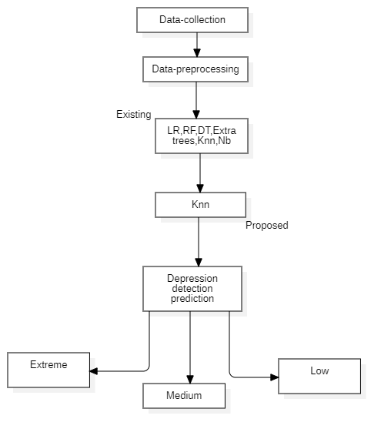

  - UMLREPRESENTATION

UML stands for Unified Modeling Language. UML is a standardized general-purpose modeling language in the field of object-oriented software engineering. The standard is managed, and was created by, the Object Management Group.
The goal is for UML to become a common language for creating models of object oriented computer software. In its current form UML is comprised of two major components: a Meta-model and a notation. In the future, some form of method or process may also be added to; or associated with, UML.
The Unified Modeling Language is a standard language for specifying, Visualization, Constructing and documenting the artifacts of software system, as well as for business modeling and other non-software systems.

The UML represents a collection of best engineering practices that have proven successful in the modeling of large and complex systems.
The UML is a very important part of developing objects oriented software and the software development process. The UML uses mostly graphical notations to express the design of software projects.

GOALS:
The Primary goals in the design of the UML are as follows:
- Provide users a ready-to-use, expressive visual modeling Language so that they can develop and exchange meaningful models.
- Provide extendibility and specialization mechanisms to extend the core concepts.
- Be independent of particular programming languages and development process.

- Provide a formal basis for understanding the modeling language
- Encourage the growth of OO tools market.
- Support higher level development concepts such as collaborations, frameworks, patterns and components.
- Integrate best practices.

4.2.1 | Use Case Diagram

A use case diagram in the Unified Modeling Language (UML) is a type of behavioral diagram defined by and created from a Use-case analysis. Its purpose is to present a graphical overview of the functionality provided by a system in terms of actors, their goals (represented as use cases), and any dependencies between those use cases. The main purpose of a use case diagram is to show what system functions are performed for which actor. Roles of the actors in the system can be depicted.

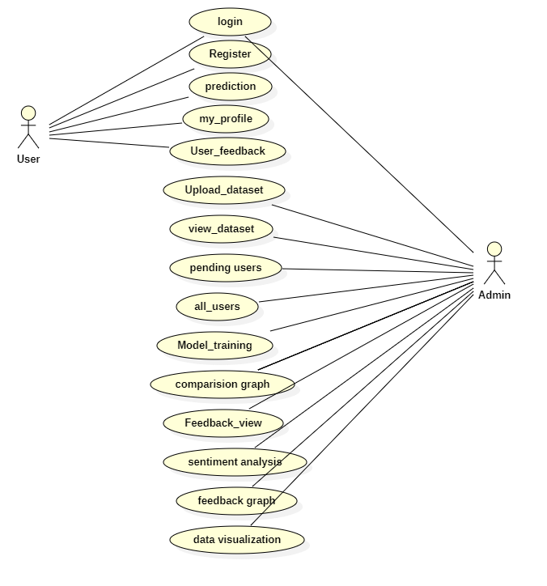
Fig 4.2.1 Use Case Diagram

4.2.2 Sequence Diagram

A sequence diagram in Unified Modeling Language (UML) is a kind of interaction diagram that shows how processes operate with one another and in what order. It is a construct of a Message

Sequence Chart. Sequence diagrams are sometimes called event diagrams, event scenarios, and timing diagrams.

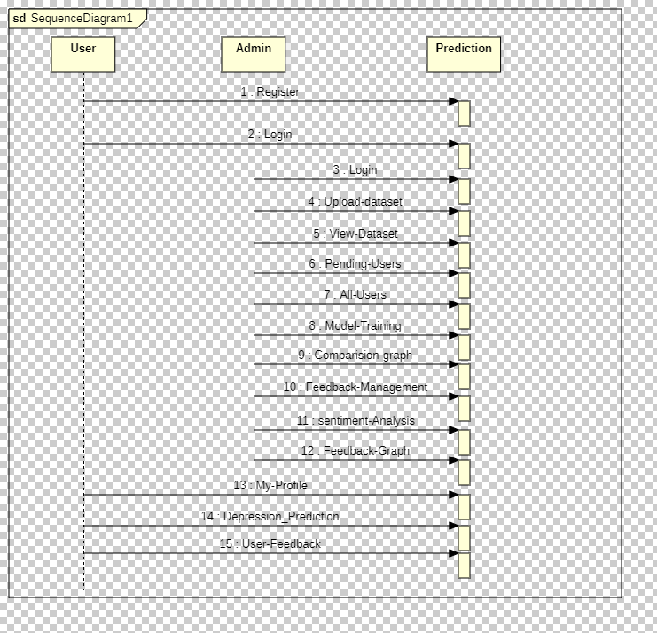

Fig 4.2.2 Sequence Diagram

4.2.3ActivityDiagram

Activity diagrams are graphical representations of workflows of stepwise activities and actions with support for choice, iteration and concurrency. In the Unified Modeling Language, activity diagrams can be used to describe the business and operational step-by-step workflows of components in a system. An activity diagram shows the overall flow of control.

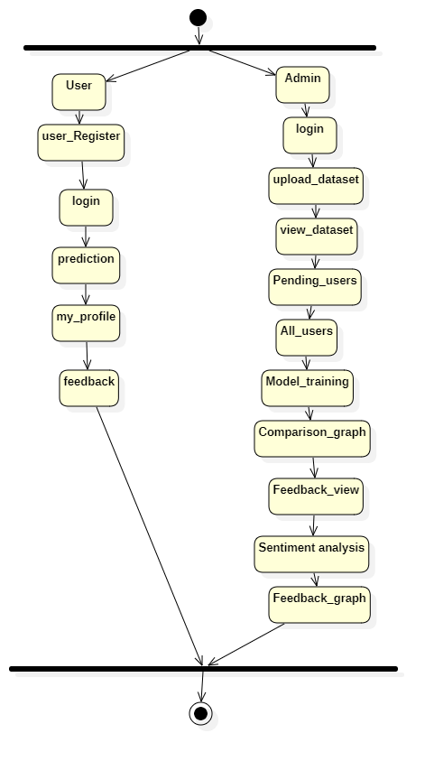

4.2.3ActivityDiagram

4.2.4 Class Diagram

In software engineering, a class diagram in the Unified Modeling Language (UML) is a type of static structure diagram that describes the structure of a system by showing the system's classes, their attributes, operations (or methods), and the relationships among the classes. It explains which class contains information.

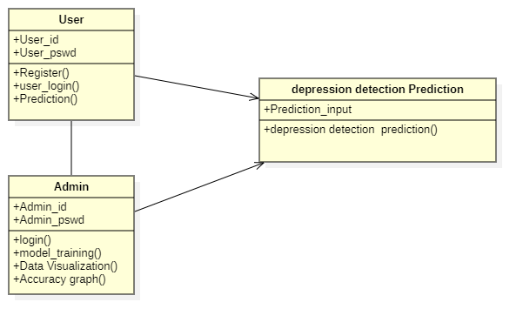

4.2.4 Class Diagram

Deployment Diagram :

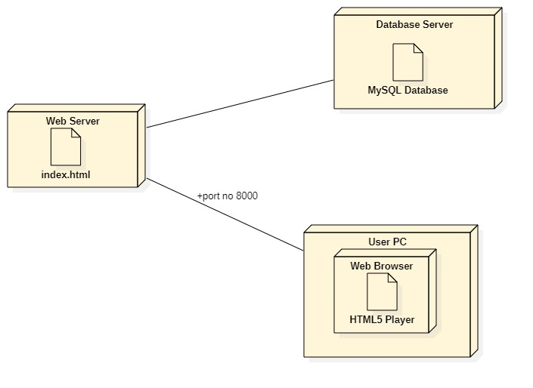

4.2.5 Deployment Diagram

Flow Chart Diagram:

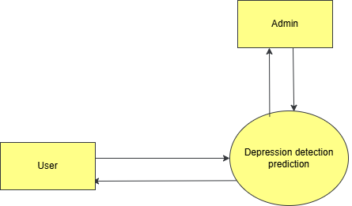

SYSTEMIMPLEMENTATION

SYSTEMIMPLEMENTATION

MODULES

Data Pre-processing: The dataset contains both numeric and non-numeric data. The categorical input features, numeric and non- numeric, are one-hot-encoded and the class labels are label-encoded to ‘1’ which represents the Depressed Class and ‘0’ which represents the Not Depressed class. Thereafter scaling is performed on the data. The input and output variables are separated and a train-test split is performed.

Models Implementation: This work uses various classification models in Machine Learning such as Logistic Regression, RF classifier, Extra Trees Classifier, Decision Tree Classifier, KNN, Gaussian Naive Bayes Classifier and Extreme Learning Machine, to predict depression by using the CDC dataset.

Hyper-parameter Tuning: Hyper-parameter Tuning is performed using Grid Search CV for each of the models and the best parameters are chosen to train the models. After model training, the models are applied on the test sets and then evaluated.

Model Evaluation: This module focuses on identifying anomalies in credit card transactions that may indicate fraudulent behavior. It utilizes specialized algorithms designed to detect irregular patterns or deviations from the norm, providing an additional layer of sophistication in fraud detection.

User Interface and Reporting: The system includes a user interface module for interacting with the system, inputting parameters, and receiving outputs. It may also generate detailed reports and visualizations to aid in the interpretation of results. This module ensures that the system is user-friendly and accessible to relevant stakeholders, such as analysts and decision-makers.

SYSTEMREQUIREMENTS

HARDWARE REQUIREMENTS
MINIMUM (Required for Execution) |  | MY SYSTEM (Development)
System | Pentium IV 2.2 GHz | i3 Processor 5th Gen
Hard Disk | 20 Gb | 500 Gb
Ram | 1 Gb | 4 Gb

SOFTWARE REQUIREMENTS
Operating System | Windows 10/11
Development Software | Python 3.10
Programming Language | Python
Integrated Development Environment (IDE) | Visual Studio Code
Front End Technologies | HTML5, CSS3, Java Script
Back End Technologies or Framework | Django
Database Language | SQL
Database (RDBMS) | MySQL
Database Software | WAMP or XAMPP Server
Web Server or Deployment Server | Django Application Development Server
Design/Modelling | Rational Rose

SOFTWARE ENVIRONMENT

What is Python programming language?
Python is a high-level, general-purpose, interpreted programming language.
1) High-level
Python is a high-level programming language that makes it easy to learn. Python doesn’t require you to understand the details of the computer in order to develop programs efficiently.
2) General-purpose
Python is a general-purpose language. It means that you can use Python in various domains including:
- Web applications
- Big data applications
- Testing
- Automation
- Data science, machine learning, and AI
- Desktop software
- Mobile apps
The targeted language like SQL which can be used for querying data from relational databases.
3) Interpreted
Python is an interpreted language. To develop a Python program, you write Python code into a file called source code.
To execute the source code, you need to convert it to the machine language that the computer can understand. And the Python interpreter turns the source code, line by line, once at a time, into the machine code when the Python program executes.

Compiled languages like Java and C# use a compiler that compiles the whole source code before the program executes.
Why Python
Python increases your productivity. Python allows you to solve complex problems in less time and fewer lines of code. It’s quick to make a prototype in Python.
Python becomes a solution in many areas across industries, from web applications to data science and machine learning.
Python is quite easy to learn in comparison with other programming languages. Python syntax is clear and beautiful.
Python has a large ecosystem that includes lots of libraries and frameworks.
Python is cross-platform. Python programs can run on Windows, Linux, and macOS.
Python has a huge community. Whenever you get stuck, you can get help from an active community.
Python developers are in high demand.

History of Python
- Python was created by Guido Van Rossum.
- The design began in the late 1980s and was first released in February 1991.
Why the name Python?
No. It wasn't named after a dangerous snake. Rossum was fan of a comedy series from late 70s. The name "Python" was adopted from the same series "Monty Python's Flying Circus".

Python Version History
Implementation started - December 1989
Internal releases – 1990
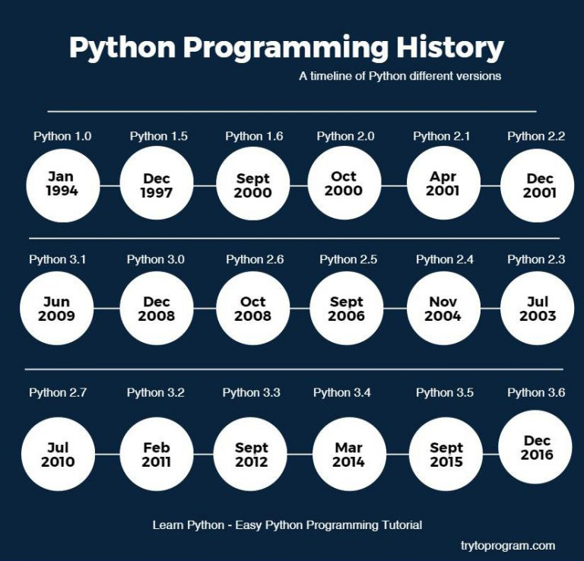
Install Python on Windows
First, download the latest version of Python from the download page.
Second, double-click the installer file to launch the setup wizard.In the setup window, you need to check the Add Python 3.8 to PATH and click Install Now to begin the installation.

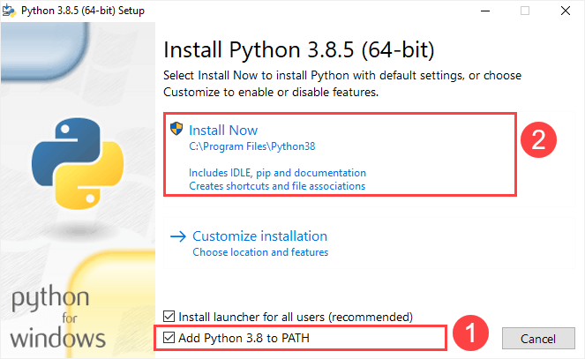
It’ll take a few minutes to complete the setup.

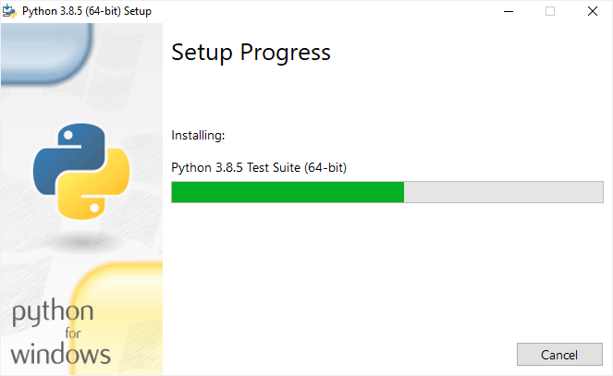
Once the setup completes, you’ll see the following window:

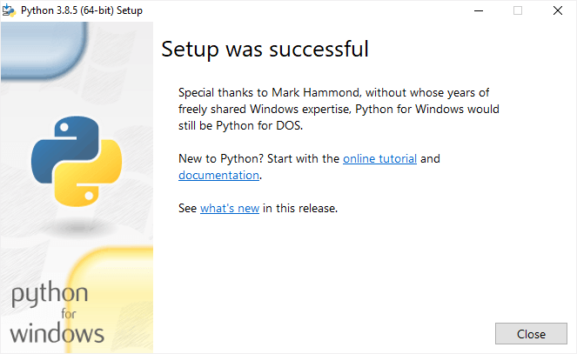
Verify the installation
To verify the installation, you open the Run window and type cmd and press Enter:

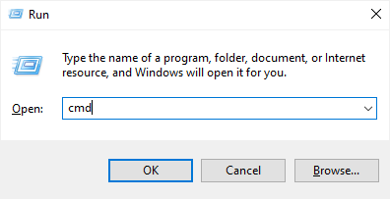
In the Command Prompt, type python command as follows:

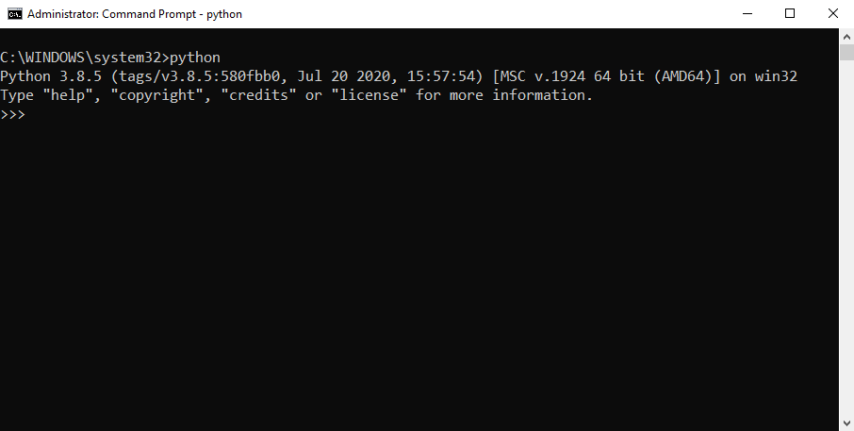
If you see the output like the above screenshot, you’ve successfully installed Python on your computer.
To exit the program, you type Ctrl-Z and press Enter.
If you see the following output from the Command Prompt after typing the python command:
'python' is not recognized as an internal or external command,
operable program or batch file.
Likely, you didn’t check the Add Python 3.8 to PATH checkbox when you install Python.
Install Python on macOS
It’s recommended to install Python on macOS using an official installer. Here are the steps:
- First, download a Python release for macOS.
- Second, run the installer by double-clicking the installer file.
- Third, follow the instruction on the screen and click the Next button until the installer completes.
Install Python on Linux
Before installing Python 3 on your Linux distribution, you check whether Python 3 was already installed by running the following command from the terminal:
python3 --version
If you see a response with the version of Python, then your computer already has Python 3 installed. Otherwise, you can install Python 3 using a package management system.

For example, you can install Python 3.10 on Ubuntu using apt:
sudo apt install python3.10
To install the newer version, you replace 3.10 with that version.
A quick introduction to the Visual Studio Code
Visual Studio Code is a lightweight source code editor. The Visual Studio Code is often called VS Code. The VS Code runs on your desktop. It’s available for Windows, macOS, and Linux.
VS Code comes with many features such as IntelliSense, code editing, and extensions that allow you to edit Python source code effectively. The best part is that the VS Code is open-source and free.
Besides the desktop version, VS Code also has a browser version that you can use directly in your web browser without installing it.
This tutorial teaches you how to set up Visual Studio Code for a Python environment so that you can edit, run, and debug Python code.
Setting up Visual Studio Code
To set up the VS Code, you follow these steps:
First, navigate to the VS Code official website and download the VS code based on your platform (Windows, macOS, or Linux).
Second, launch the setup wizard and follow the steps.
Once the installation completes, you can launch the VS code application:
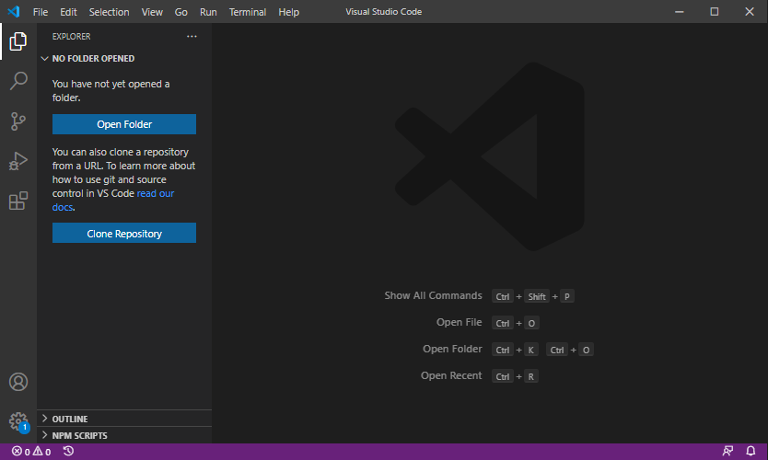
Install Python Extension
To make the VS Code works with Python, you need to install the Python extension from the Visual Studio Marketplace.
The following picture illustrates the steps:
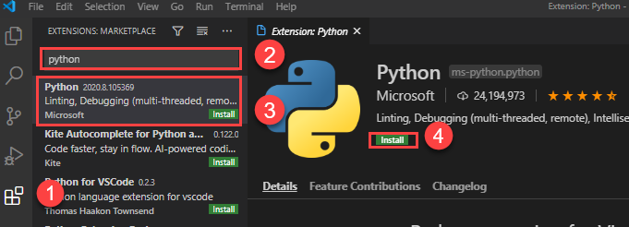
- First, click the Extensions tab.
- Second, type the python extension pack keyword on the search input.
- Third, click the Python extension pack. It’ll show detailed information on the right pane.
- Finally, click the Install button to install the Python extension.
Now, you’re ready to develop the first program in Python.
Creating a new Python project
First, create a new folder called helloworld.
Second, launch the VS code and open the helloworld folder.

Third, create a new app.py file and enter the following code and save the file:
print('Hello, World!')
Code language: Python (python)
The print() is a built-in function that displays a message on the screen. In this example, it’ll show the message 'Hello, Word!'.
What is a function
When you sum two numbers, that’s a function.And when you multiply two numbers, that’s also a function.
Each function takes your inputs, applies some rules, and returns a result.
In the above example, the print() is a function. It accepts a string and shows it on the screen.
Python has many built-in functions like the print() function to use them out of the box in your program.
In addition, Python allows you to define your functions, which you’ll learn how to do it later.
Executing the Python Hello World program
To execute the app.py file, you first launch the Command Prompt on Windows or Terminal on macOS or Linux.
Then, navigate to the helloworld folder.
After that, type the following command to execute the app.py file:
python app.py
Code language: Python (python)
If you use macOS or Linux, you use python3 command instead:
python3 app.py
Code language: CSS (css)
If everything is fine, you’ll see the following message on the screen:
Hello, World!

Code language: Python (python)
If you use VS Code, you can also launch the Terminal within the VS code by:
- Accessing the menu Terminal > New Terminal
- Or using the keyboard shortcut Ctrl+Shift+`.
Typically, the backtick key (`) locates under the Esc key on the keyboard.

Python IDLE
Python IDLE is the Python Integration Development Environment (IDE) that comes with the Python distribution by default.
The Python IDLE is also known as an interactive interpreter. It has many features such as:
- Code editing with syntax highlighting
- Smart indenting
- And auto-completion
In short, the Python IDLE helps you experiment with Python quickly in a trial-and-error manner.
The following shows you step by step how to launch the Python IDLE and use it to execute the Python code:
First, launch the Python IDLE program:
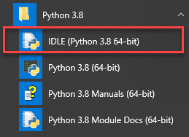
A new Python Shell window will display as follows:
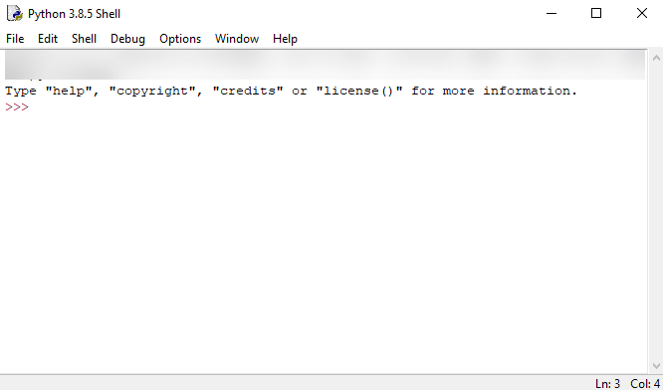
Now, you can enter the Python code after the cursor >>> and press Enter to execute it.
For example, you can type the code print('Hello, World!') and press Enter, you’ll see the message Hello, World! immediately on the screen:
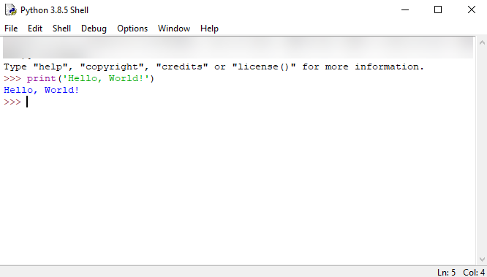

Python Syntax
Whitespace and indentation
If you’ve been working in other programming languages such as Java, C#, or C/C++, you know that these languages use semicolons (;) to separate the statements.

However, Python uses whitespace and indentation to construct the code structure.
The following shows a snippet of Python code:
# define main function to print out something
def main():
i = 1
max = 10
while (i < max):
print(i)
i = i + 1
# call function main
main()
The meaning of the code isn’t important to you now. Please pay attention to the code structure instead.
At the end of each line, you don’t see any semicolon to terminate the statement. And the code uses indentation to format the code.
By using indentation and whitespace to organize the code, Python code gains the following advantages:
- First, you’ll never miss the beginning or ending code of a block like in other programming languages such as Java or C#.
- Second, the coding style is essentially uniform. If you have to maintain another developer’s code, that code looks the same as yours.
- Third, the code is more readable and clearer in comparison with other programming languages.
Comments
The comments are as important as the code because they describe why a piece of code was written.
When the Python interpreter executes the code, it ignores the comments.
In Python, a single-line comment begins with a hash (#) symbol followed by the comment. For

example:
# This is a single line comment in Python
Continuation of statements
Python uses a newline character to separate statements. It places each statement on one line.
However, a long statement can span multiple lines by using the backslash (\) character.
The following example illustrates how to use the backslash (\) character to continue a statement in the second line:
if (a == True) and (b == False) and \
(c == True):
print("Continuation of statements")
Identifiers
Identifiers are names that identify variables, functions, modules, classes, and other objects in Python.
The name of an identifier needs to begin with a letter or underscore (_). The following characters can be alphanumeric or underscore.
Python identifiers are case-sensitive. For example, the counter and Counter are different identifiers.
In addition, you cannot use Python keywords for naming identifiers.
Keywords
Some words have special meanings in Python. They are called keywords.
The following shows the list of keywords in Python:
False class finally is return
None continue for lambda try
True def from nonlocal while
and del global not with
aselif if or yield
assert else import pass

Python is a growing and evolving language. So, its keywords will keep increasing and changing.
Python provides a special module for listing its keywords called keyword.
To find the current keyword list, you use the following code:
import keyword
print(keyword.kwlist)
String literals
Python uses single quotes ('), double quotes ("), triple single quotes (''') and triple-double quotes (""") to denote a string literal.
The string literal need to be surrounded with the same type of quotes. For example, if you use a single quote to start a string literal, you need to use the same single quote to end it.
The following shows some examples of string literals:
s = 'This is a string'
print(s)
s = "Another string using double quotes"
print(s)
s = ''' string can span
multiple line '''
print(s)

SYSTEM TESTING

SYSTEMTEST

Types of Software Testing: Different Testing Types with Details
We, as testers, are aware of the various types of Software Testing like Functional Testing, Non-Functional Testing, Automation Testing, Agile Testing, and their sub-types, etc.
Each type of testing has its own features, advantages, and disadvantages as well. However, in this tutorial, we have covered mostly each and every type of software testing which we usually use in our day-to-day testing life.
Different Types of Software Testing
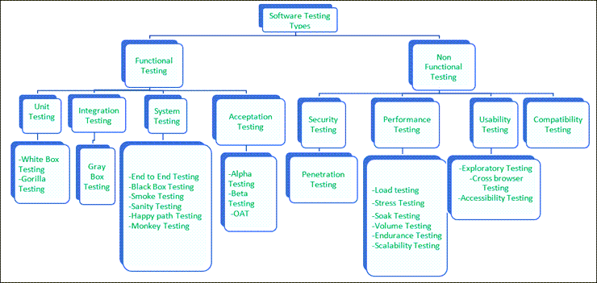

Functional Testing
There are four main types of functional testing.
#1) Unit Testing
Unit testing is a type of software testing which is done on an individual unit or component to test its corrections. Typically, Unit testing is done by the developer at the application development phase. Each unit in unit testing can be viewed as a method, function, procedure, or object. Developers often use test automation tools such as NUnit, Xunit, JUnit for the test execution.
Unit testing is important because we can find more defects at the unit test level.
For example, there is a simple calculator application. The developer can write the unit test to check if the user can enter two numbers and get the correct sum for addition functionality.

a) White Box Testing
White box testing is a test technique in which the internal structure or code of an application is visible and accessible to the tester. In this technique, it is easy to find loopholes in the design of an application or fault in business logic. Statement coverage and decision coverage/branch coverage are examples of white box test techniques.
b) Gorilla Testing
Gorilla testing is a test technique in which the tester and/or developer test the module of the application thoroughly in all aspects. Gorilla testing is done to check how robust your application is.
For example, the tester is testing the pet insurance company’s website, which provides the service of buying an insurance policy, tag for the pet, Lifetime membership. The tester can focus on any one module, let’s say, the insurance policy module, and test it thoroughly with positive and negative test scenarios.

#2) Integration Testing
Integration testing is a type of software testing where two or more modules of an application are logically grouped together and tested as a whole. The focus of this type of testing is to find the defect on interface, communication, and data flow among modules. Top-down or Bottom-up approach is used while integrating modules into the whole system.
This type of testing is done on integrating modules of a system or between systems. For example, a user is buying a flight ticket from any airline website. Users can see flight details and payment information while buying a ticket, but flight details and payment processing are two different systems. Integration testing should be done while integrating of airline website and payment processing system.
a) Gray box testing
As the name suggests, gray box testing is a combination of white-box testing and black-box testing. Testers have partial knowledge of the internal structure or code of an application.

#3) System Testing
System testing is types of testing where tester evaluates the whole system against the specified requirements.
a) End to End Testing
It involves testing a complete application environment in a situation that mimics real-world use,

such as interacting with a database, using network communications, or interacting with other
hardware, applications, or systems if appropriate.
For example, a tester is testing a pet insurance website. End to End testing involves testing of buying an insurance policy, LPM, tag, adding another pet, updating credit card information on users’ accounts, updating user address information, receiving order confirmation emails and policy documents.

b) Black Box Testing
Blackbox testing is a software testing technique in which testing is performed without knowing the internal structure, design, or code of a system under test. Testers should focus only on the input and output of test objects.
Detailed information about the advantages, disadvantages, and types of Black Box testing can be found here.

c) Smoke Testing
Smoke testing is performed to verify that basic and critical functionality of the system under test is working fine at a very high level.
Whenever a new build is provided by the development team, then the Software Testing team validates the build and ensures that no major issue exists. The testing team will ensure that the build is stable, and a detailed level of testing will be carried out further.
For example, tester is testing pet insurance website. Buying an insurance policy, adding another pet, providing quotes are all basic and critical functionality of the application. Smoke testing for this website verifies that all these functionalities are working fine before doing any in-depth testing.

d) Sanity Testing
Sanity testing is performed on a system to verify that newly added functionality or bug fixes are working fine. Sanity testing is done on stable build. It is a subset of the regression test.
For example, a tester is testing a pet insurance website. There is a change in the discount for buying a policy for second pet. Then sanity testing is only performed on buying insurance policy module.

e) Happy path Testing
The objective of Happy Path Testing is to test an application successfully on a positive flow. It does not look for negative or error conditions. The focus is only on valid and positive inputs through which the application generates the expected output.
f) Monkey Testing
Monkey Testing is carried out by a tester, assuming that if the monkey uses the application, then how random input and values will be entered by the Monkey without any knowledge or understanding of the application.
The objective of Monkey Testing is to check if an application or system gets crashed by providing random input values/data. Monkey Testing is performed randomly, no test cases are scripted ,and it is not necessary to beawareof the full functionality of the system.

#4) Acceptance Testing
Acceptance testing is a type of testing where client/business/customer test the software with real time business scenarios.
The client accepts the software only when all the features and functionalities work as expected. This is the last phase of testing, after which the software goes into production. This is also called User Acceptance Testing (UAT).

a) Alpha Testing
Alpha testing is a type of acceptance testing performed by the team in an organization to find as many defects as possible before releasing software to customers.
For example, the pet insurance website is under UAT. UAT team will run real-time scenarios like buying an insurance policy, buying annual membership, changing the address, ownership transfer of the pet in a same way the user uses the real website. The team can use test credit card information to process payment-related scenarios.
b) Beta Testing
Beta Testing is a type of software testing which is carried out by the clients/customers. It is performed in the Real Environment before releasing the product to the market for the actual end-users.
Beta Testing is carried out to ensure that there are no major failures in the software or product, and it satisfies the business requirements from an end-user perspective. Beta Testing is successful when the customer accepts the software.

Usually, this testing is typically done by the end-users. This is the final testing done before releasing the application for commercial purposes. Usually, the Beta version of the software or product released is limited to a certain number of users in a specific area.
So, the end-user uses the software and shares the feedback with the company. The company then takes necessary action before releasing the software worldwide.
c) Operational acceptance testing (OAT)
Operational acceptance testing of the system is performed by operations or system administration staff in the production environment. The purpose of operational acceptance testing is to make sure that the system administrators can keep the system working properly for the users in a real-time environment.
The focus of the OAT is on the following points:
- Testing of backup and restore.
- Installing, uninstalling, upgrading software.
- The recovery process in case of natural disaster.
- User management.
- Maintenance of the software.

Non-Functional Testing
There are four main types of functional testing.
#1) Security Testing
It is a type of testing performed by a special team. Any hacking method can penetrate the system.
Security Testing is done to check how the software, application, or website is secure from internal and/or external threats. This testing includes how much software is secure from malicious programs, viruses and how secure & strong the authorization and authentication processes are.
It also checks how software behaves for any hacker’s attack & malicious programs and how software is maintained for data security after such a hacker attack.
a) Penetration Testing
Penetration Testing or Pen testing is the type of security testing performed as an authorized cyberattack on the system to find out the weak points of the system in terms of security.
Pen testing is performed by outside contractors, generally known as ethical hackers. That is

why it is also known as ethical hacking. Contractors perform different operations like SQL injection, URL manipulation, Privilege Elevation, session expiry, and provide reports to the organization.
Notes: Do not perform the Pen testing on your laptop/computer. Always take written permission to do pen tests.
#2) Performance Testing
Performance testing is testing of an application’s stability and response time by applying load.
The word stability means the ability of the application to withstand in the presence of load. Response time is how quickly an application is available to users. Performance testing is done with the help of tools. Loader.IO, JMeter, LoadRunner, etc. are good tools available in the market.
a) Load testing
Load testing is testing of an application’s stability and response time by applying load, which is equal to or less than the designed number of users for an application.
For example, your application handles 100 users at a time with a response time of 3 seconds, then load testing can be done by applying a load of the maximum of 100 or less than 100 users. The goal is to verify that the application is responding within 3 seconds for all the users.
b) Stress Testing
Stress testing is testing an application’s stability and response time by applying load, which is more than the designed number of users for an application.
For example, your application handles 1000 users at a time with a response time of 4 seconds, then stress testing can be done by applying a load of more than 1000 users. Test the application with 1100,1200,1300 users and notice the response time. The goal is to verify the stability of an application under stress.
c) Scalability Testing
Scalability testing is testing an application’s stability and response time by applying load, which is more than the designed number of users for an application.
For example, your application handles 1000 users at a time with a response time of 2 seconds, then scalability testing can be done by applying a load of more than 1000 users and gradually increasing the number of users to find out where exactly my application is crashing.
Let’s say my application is giving response time as follows:
- 1000 users -2 sec
- 1400 users -2 sec
- 4000 users -3 sec

- 5000 users -45 sec
- 5150 users- crash – This is the point that needs to identify in scalability testing
d) Volume testing (flood testing)
Volume testing is testing an application’s stability and response time by transferring a large volume of data to the database. Basically, it tests the capacity of the database to handle the data.
e) Endurance Testing (Soak Testing)
Endurance testing is testing an application’s stability and response time by applying load continuously for a longer period to verify that the application is working fine.
For example, car companies soak testing to verify that users can drive cars continuously for hours without any problem.
#3) Usability Testing
Usability testing is testing an application from the user’s perspective to check the look and feel and user-friendliness.
For example, there is a mobile app for stock trading, and a tester is performing usability testing. Testers can check the scenario like if the mobile app is easy to operate with one hand or not, scroll bar should be vertical, background colour of the app should be black and price of and stock is displayed in red or green colour.
The main idea of usability testing of this kind of app is that as soon as the user opens the app, the user should get a glance at the market.
a) Exploratory testing
Exploratory Testing is informal testing performed by the testing team. The objective of this testing is to explore the application and look for defects that exist in the application. Testers use the knowledge of the business domain to test the application. Test charters are used to guide the exploratory testing.
b) Cross browser testing
Cross browser testing is testing an application on different browsers, operating systems, mobile devices to see look and feel and performance.
Why do we need cross-browser testing? The answer is different users use different operating systems, different browsers, and different mobile devices. The goal of the company is to get a good user experience regardless of those devices.
Browser stack provides all the versions of all the browsers and all mobile devices to test the application. For learning purposes, it is good to take the free trial given by browser stack for a few days.

c) Accessibility Testing
The aim of Accessibility Testing is to determine whether the software or application is accessible
for disabled people or not.
Here, disability means deafness, colour blindness, mentally disabled, blind, old age, and other disabled groups. Various checks are performed, such as font size for visually disabled, colour and contrast for colour blindness, etc.
#4) Compatibility testing
This is a testing type in which it validates how software behaves and runs in a different environment, web servers, hardware, and network environment.

SCREENSHOTS

SCREENSHOTS



Fig7.1This fig shows the first screen of our project

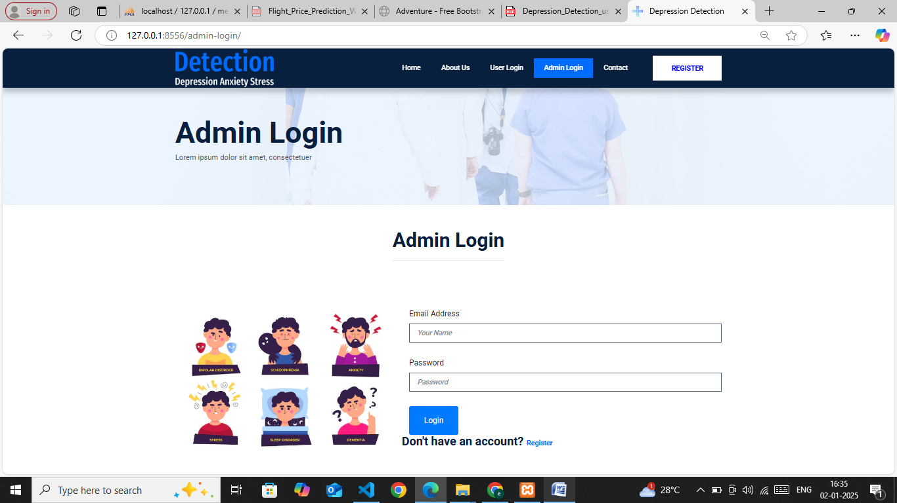

Fig7.2 Admin Login

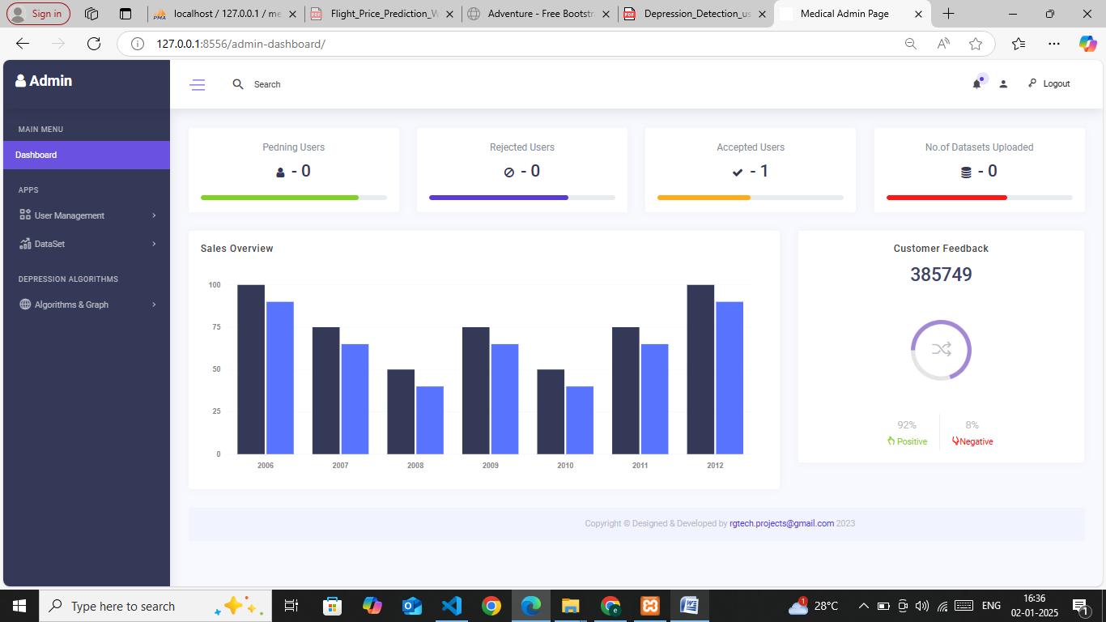

Fig7.3 Admin Dashboard

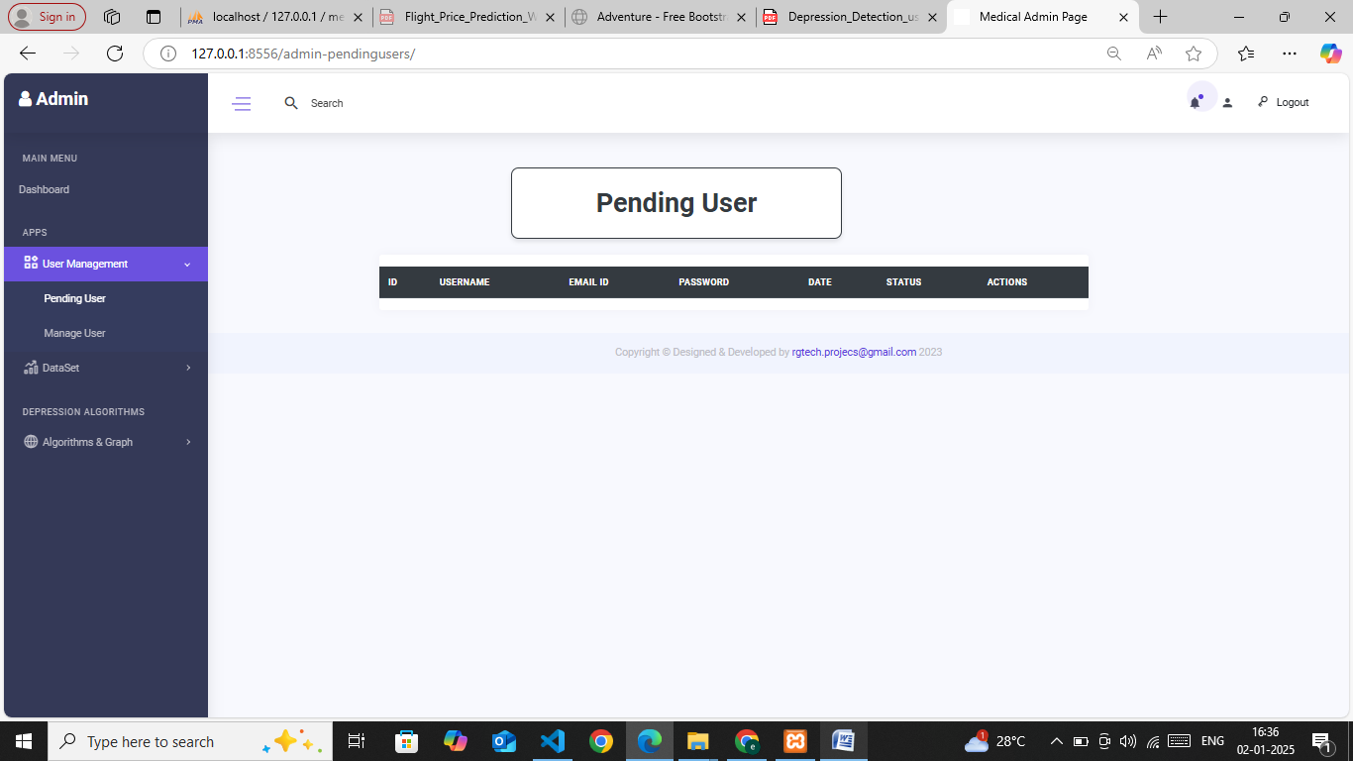

Fig7.4 Pending Users

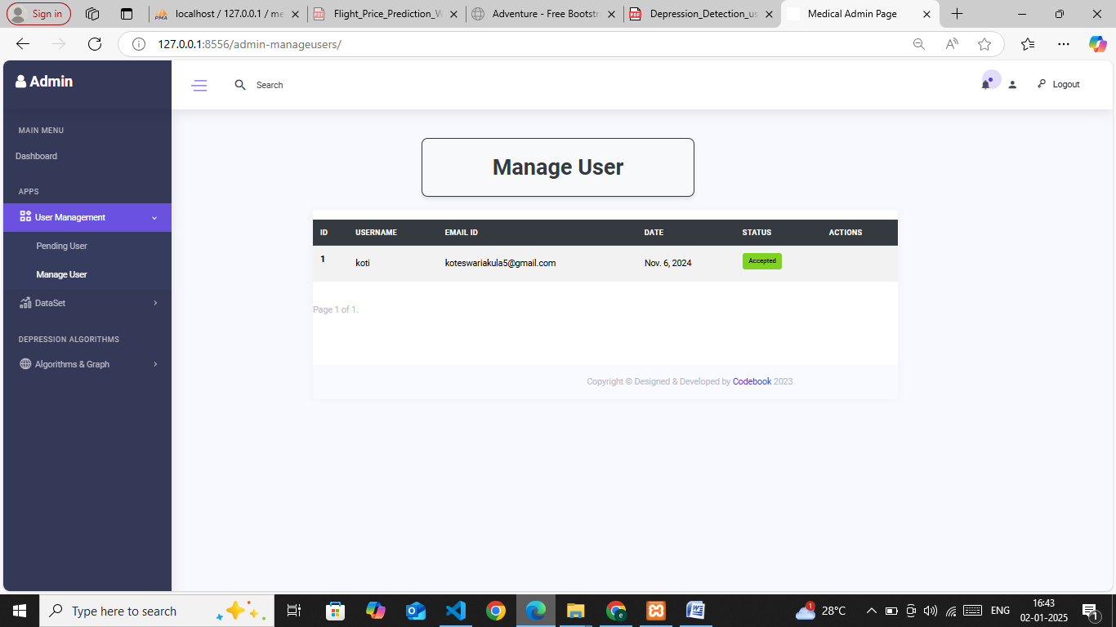

Fig7.4 Manage Users

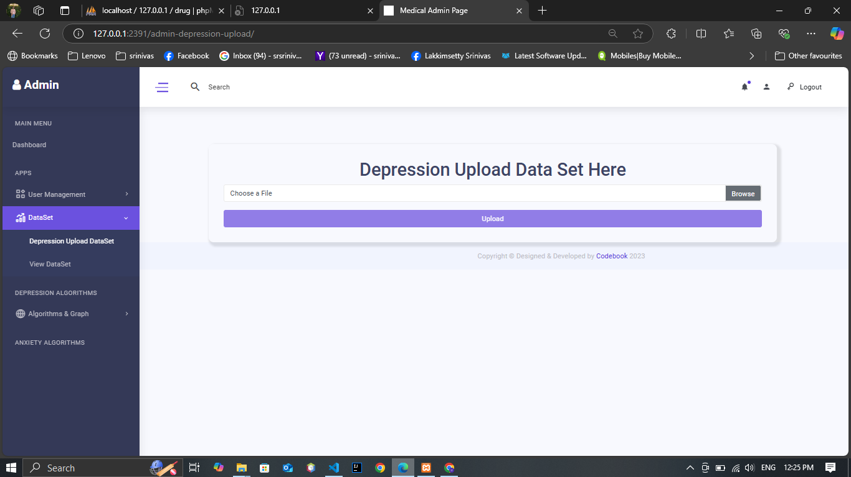

Fig7.5 Upload Dataset

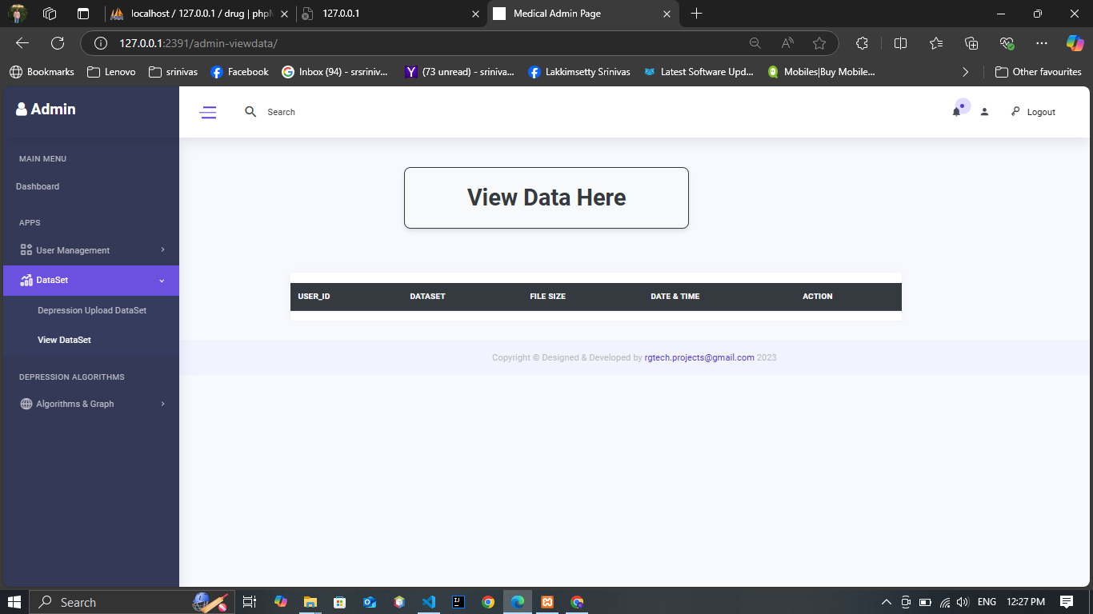

Fig7.5 View Dataset

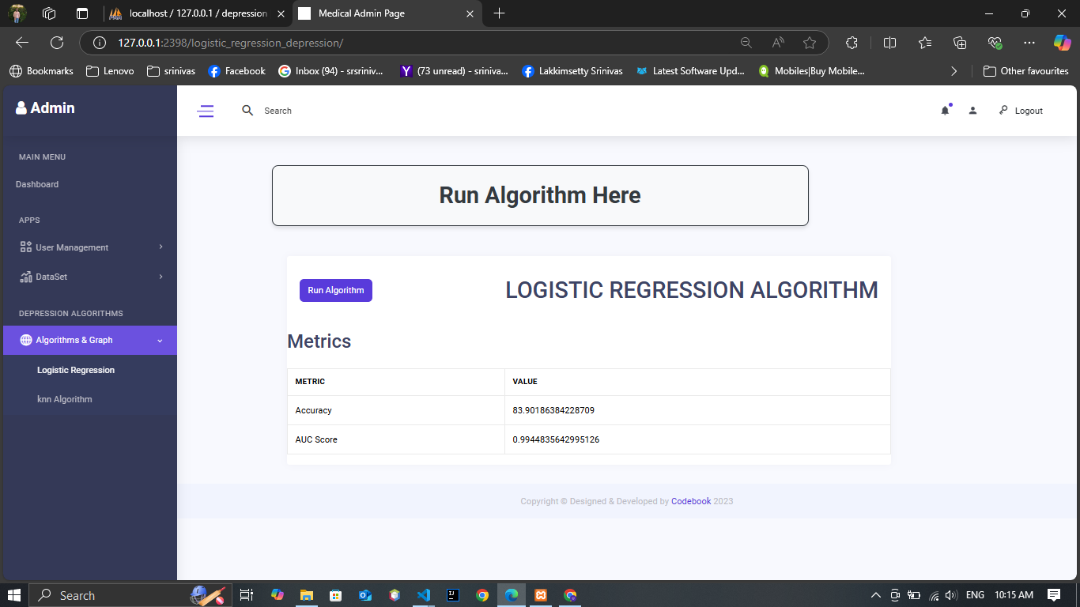

Fig7.6 Logistic Algorithm
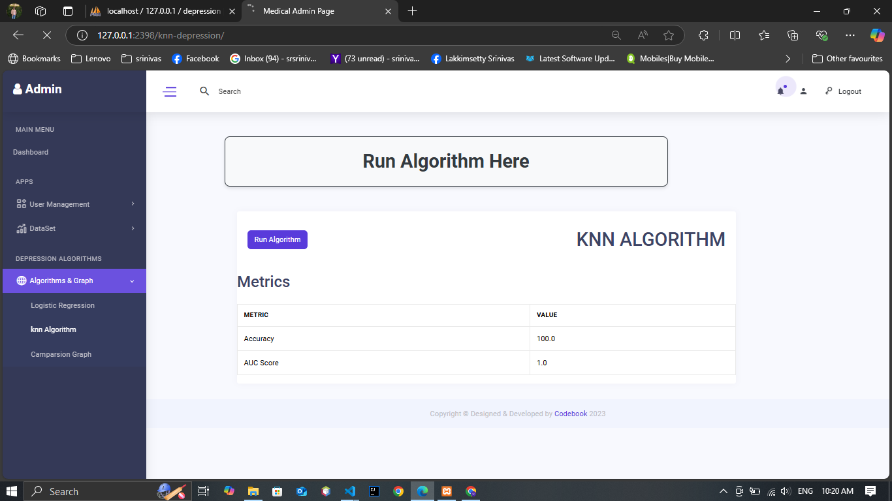

Fig7.7 KNN Algorithm

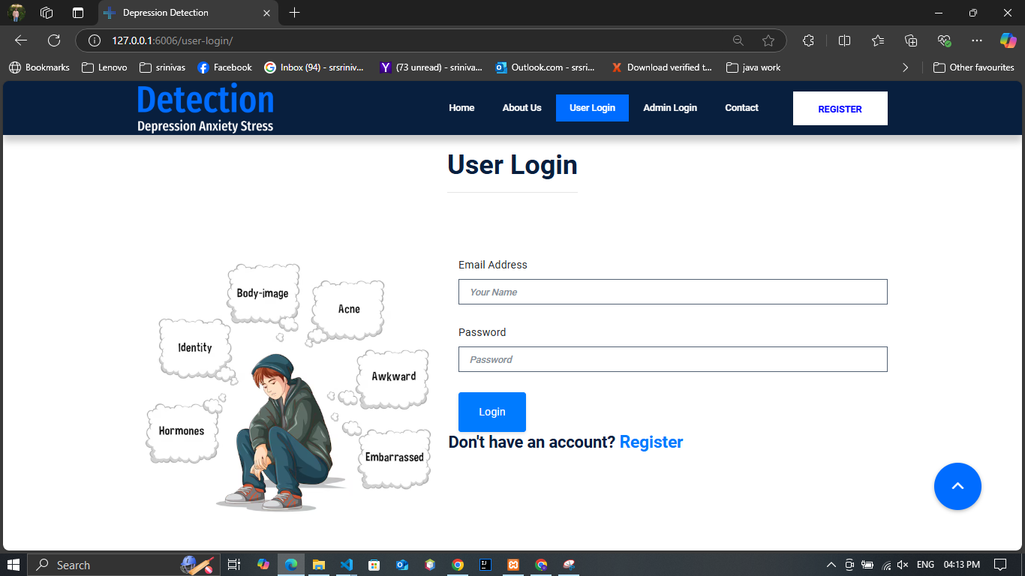

Fig7.8 User Login

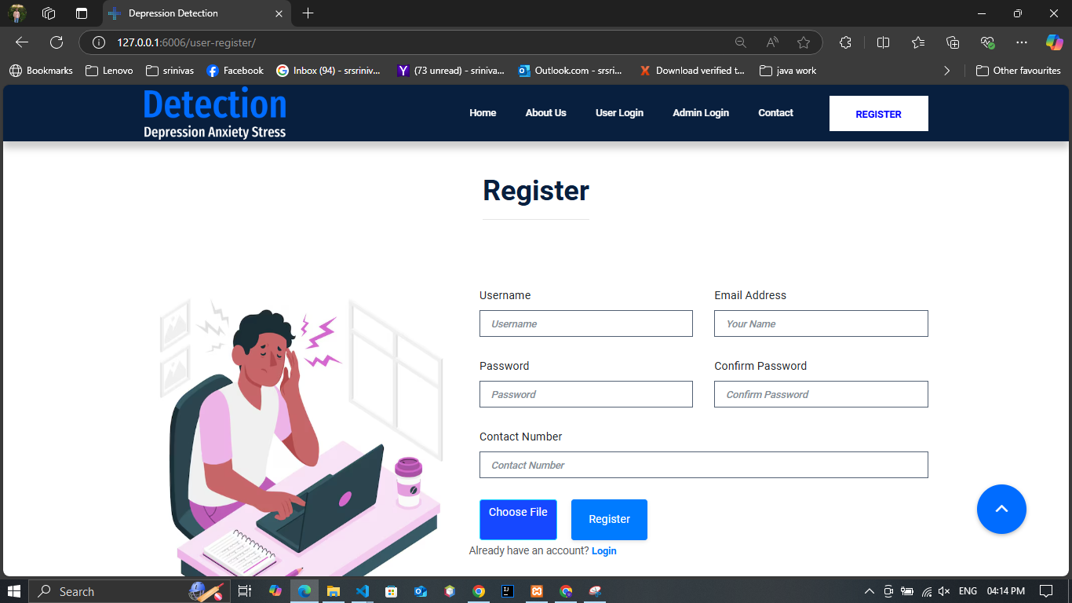

Fig7.9 User Register

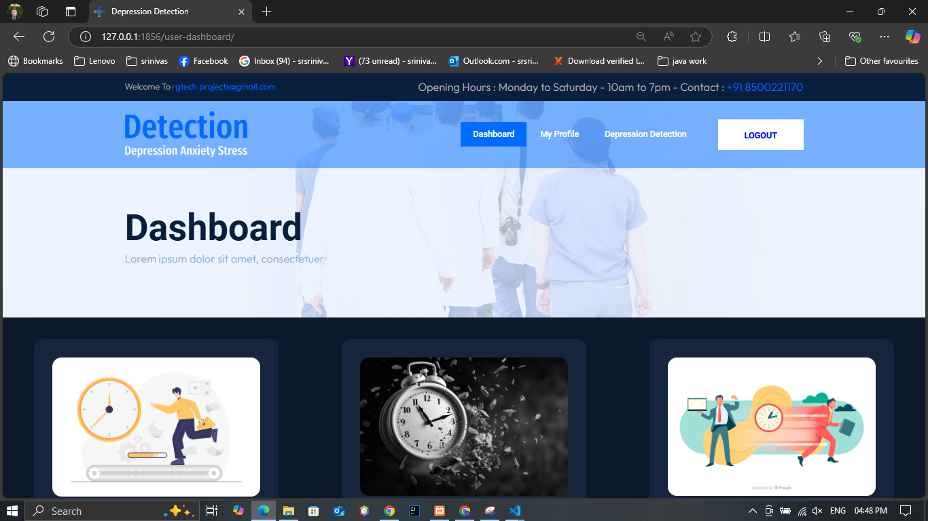

Fig 8.0 User Register

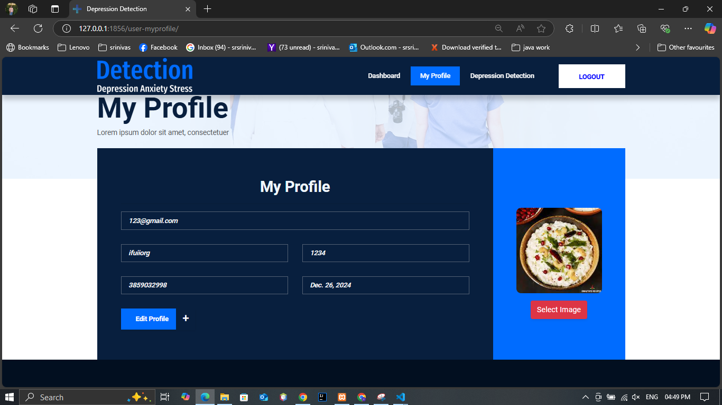

Fig 8.1 User Profile

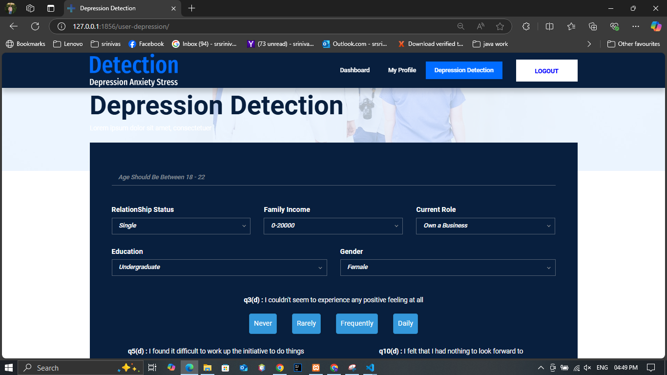

Fig 8.2 Prediction From

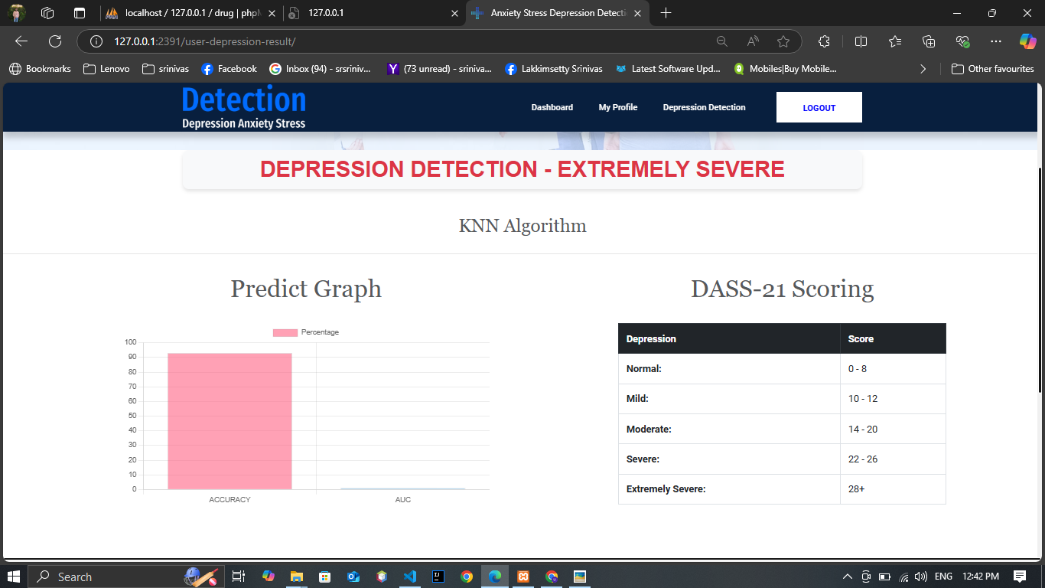

Fig 8.2 Prediction From Result

CONCLUSION
&

FUTUREWORK

CONCLUSION AND FUTURE WORK

Conclusion

This project presented CryptoQNet, a quantum computing–based framework for cryptocurrency market analysis and price prediction. Since cryptocurrency markets are highly volatile and complex, classical statistical methods and traditional deep learning models often face difficulties in capturing nonlinear patterns and sudden price fluctuations. To overcome these limitations, the proposed system combined quantum feature mapping, variational quantum circuits, and a quantum recurrent neural network structure.

The model was trained using historical cryptocurrency market data and evaluated using standard performance metrics such as MAE, RMSE, and MAPE. The results showed that CryptoQNet provides improved prediction accuracy compared to classical models like LSTM and GRU. Overall, the proposed system proves that quantum machine learning can play an important role in future financial forecasting systems by offering better feature representation, improved scalability, and efficient computation.

Future Enhancements

In the future, CryptoQNet can be further improved in several ways. The system can be extended to support multiple cryptocurrencies at the same time instead of focusing on a single market. Additional features such as social media sentiment, global economic indicators, and blockchain transaction data can also be integrated to improve prediction reliability.

The model can be enhanced by using advanced quantum architectures and deeper quantum circuits for improved learning capability. Further optimization can be done to reduce noise and improve stability when running the model on real quantum hardware. In addition, the system can be integrated with real-time cryptocurrency trading platforms to provide live market predictions and decision support.

Finally, the system can be developed into a complete intelligent financial assistant that provides forecasting, risk analysis, and automated investment suggestions using quantum-enhanced models.

REFERENCES.

REFERENCES

[1] K. Min, J. Yoon, M. Kang, D. Lee, E. Park, and J. Han, “Detecting depression on video logs using audiovisual features,” no. 2023, doi: 10.1057/s41599-023-02313-6.

[2] H. Zhang, H. Wang, S. Han, W. Li, and L. Zhuang, “Computer Methods and Programs in Biomedicine Detecting depression tendency with multimodal features,” Comput. Methods Programs Biomed., vol. 240, no. January 2022, p. 107702, 2023, doi: 10.1016/j.cmpb.2023.107702.

[3] J. Jovel, R. Greiner, and R. Greiner, “An Introduction to Machine Learning Approaches for Biomedical Research,” vol. 8, no. December, pp. 1–15, 2021, doi: 10.3389/fmed.2021.771607.

[4] J. Maurya and S. Prakash, “Heart Disease Prediction and Diagnosis Using IoT, ML, and Cloud Computing,” in International Conference on Innovative Computing and Communications, A. E. Hassanien, O. Castillo, S. Anand, and A. Jaiswal, Eds., Singapore: Springer Nature Singapore, 2024, pp. 419–430.

[5] I. Conference, “Feature Selection and Imbalanced Data Handling for Depression Detection : Feature Select ion and Imbalanced Data Handling for Depression Detection,” no. September 2023, 2018, doi: 10.1007/978-3-030-05587-5.

[6] R. Islam, M. A. Kabir, A. Ahmed, A. R. M. Kamal, and H. Wang, “Depression detection from social network data using machine learning techniques,” Heal. Inf. Sci. Syst., vol. 6, no. 1, pp. 1–12, 2018, doi: 10.1007/s13755-018-0046-0.

[7] H. Alsagri, “Machine Learning-based Approach for Depression Detection in Twitter Using Content and Activity Features,” vol. 1, pp. 1–16.

[8] A. Ahmed, R. Sultana, M. T. R. Ullas, M. Begom, M. M. I. Rahi, and M. A. Alam, “A Machine Learning Approach to detect Depression and Anxiety using Supervised Learning,” 2020 IEEE Asia-Pacific Conf. Comput. Sci. Data Eng. CSDE 2020, pp. 4–9, 2020, doi: 10.1109/CSDE50874.2020.9411642.

[9] S. J. T. J, I. J. Jacob, and A. K. Mandava, “D-ResNet-PVKELM : deep neural network and paragraph vector based kernel extreme machine learning model for multimodal depression analysis,” pp. 25973–26004, 2023.

[10] D. Kumar, U. Subrajeet, M. Niraj, and K. Singh, “An early assessment of Persistent Depression Disorder using machine learning algorithm,” Multimed. Tools Appl., no. 0123456789, 2023, doi: 10.1007/s11042-023-17369-4.

[11] D. Pokrajac, “The successful discrimination of depression from EEG could be attributed to proper feature extraction and not to a particular classification method,” vol. 0123456789, pp. 443–455, 2020, doi: 10.1007/s11571-020-09581-x.

[12] A. Albtoush and M. Ferna, “Quick extreme learning machine for large-scale classification,” vol. 8, pp. 5923–5938, 2022, doi: 10.1007/s00521-021-06727-8.

[13] J. Wang, S. Lu, S. Wang, and Y. Zhang, “A review on extreme learning machine,” pp. 41611–41660, 2022.

[14] Lu, Shengfu; Liu, Sa; Li, Mi; Shi, Xin; Li, Richeng," Depression Classification Model Based on Emotionally Related EyeMovement Data and Kernel Extreme Learning Machine", Journal of Medical Imaging and Health Informatics, Volume 10, Number 11, November 2020, pp. 2668-2674(7), https://doi.org/10.1166/jmihi.2020.3198.

[15] https://pandas.pydata.org/docs/ (accessed on 25-12-2023).

[16] https://matplotlib.org/stable/plot_types/stats/hist_plot.html (accessed on 25-12-2023).

[17] https://en.wikipedia.org/wiki/Scikit-learn (accessed on 25-12- 2023).

[18] https://numpy.org/doc/stable/user/whatisnumpy.html (accessed on 25-12-2023).

[19] https://www.geeksforgeeks.org/ml-logistic-regression-usingpython/ (accessed on 26-12-2023).

[20] https://www.geeksforgeeks.org/random-forest-classifier-using

BIBLIOGRAPHY
- W3 School – (https://www.w3schools.com/python/)
- Geek for Geeks – (https://www.geeksforgeeks.org/python-programming-language/learn-python-tutorial/)
- Python Official Documentation – (https://docs.python.org/3/tutorial/)
- Tutorials Point – (https://www.tutorialspoint.com/python/index.htm)
- Real Python – (https://realpython.com/)
- Django for Beginners – (https://djangoforbeginners.com/introduction/)
- Guru99 – (https://www.guru99.com/django-tutorial.html)

APPENDIX

SOURCE CODE

Admins.py

from django.shortcuts import render, redirect
from django.contrib import messages
from django.core.paginator import Paginator
from .models import depression_Upload_dataset
from userapp.models import UserDetails, Predict_details
import numpy as np
import pandas as pd
from sklearn.model_selection import train_test_split
from sklearn.linear_model import LogisticRegression
from sklearn.neighbors import KNeighborsClassifier
from sklearn.metrics import accuracy_score, roc_auc_score
from keras.models import Sequential
from keras.layers import Dense
from itertools import chain
from userapp.models import UserDetails, Predict_details
from adminapp.models import depression_Upload_dataset

def lr_alg(req):
return render(req, 'admin/Logistic-Regression.html')

def rf_alg(req):
return render(req, 'admin/Random-Forest.html')
def knn_alg(req):
return render(req, 'admin/KNN.html')

# Admin dashboard views
def admin_index(request):
messages.success(request, 'Login successful')
all_users_count = UserDetails.objects.all().count()
pending_users_count = UserDetails.objects.filter(user_status='pending').count()
rejected_users_count = UserDetails.objects.filter(user_status='Rejected').count()
accepted_users_count = UserDetails.objects.filter(user_status='Accepted').count()
datasets_count = depression_Upload_dataset.objects.all().count()
no_of_predicts = Predict_details.objects.all().count()
return render(request, 'admin/index.html', {
'a': pending_users_count,
'b': all_users_count,
'c': rejected_users_count,
'd': accepted_users_count,
'e': datasets_count,
'f': no_of_predicts
})

def admin_pending(request):
users = UserDetails.objects.filter(user_status='pending')
context = {'u': users}
return render(request, "admin/pending.html", context)

def Admin_Reject_Btn(request, x):
user = UserDetails.objects.get(user_id=x)
user.user_status = 'Rejected'
user.save()
messages.warning(request, 'Rejected')
return redirect('pending')

def Admin_accept_Btn(req, x):
user = UserDetails.objects.get(user_id=x)
user.user_status = 'Accepted'
user.save()
messages.success(req, 'Accepted')
return redirect('pending')

def admin_manage(request):
a = UserDetails.objects.all()
paginator = Paginator(a, 5)
page_number = request.GET.get('page')
post = paginator.get_page(page_number)
return render(request, "admin/manage.html", {'all': post})

# Views for handling dataset uploads

def depression_admin_upload(request):
if request.method == 'POST':
file = request.FILES['data_file']
file_size = str((file.size) / 1024) + ' kb'
depression_Upload_dataset.objects.create(File_size=file_size, Dataset=file)
messages.success(request, 'Your dataset was uploaded.')
return render(request, "admin/depression-upload-data.html")

# Delete a dataset
def delete_dataset(request, id):
try:
depression_Upload_dataset.objects.get(user_id=id).delete()
except depression_Upload_dataset.DoesNotExist:
pass

pass
return redirect('view')

# View combined datasets
def admin_view(request):
dataset = depression_Upload_dataset.objects.all()
all_datasets = list(chain( dataset))
paginator = Paginator(all_datasets, 5)
page_number = request.GET.get('page')
post = paginator.get_page(page_number)
return render(request, "admin/view-data.html", {'data': all_datasets, 'user': post})

def view_view(request):
data = depression_Upload_dataset.objects.last()
filed = str(data.Dataset)
dfd = pd.read_csv(f'./media/{filed}')
tabled = dfd.to_html(table_id='data_table')

return render(request, 'admin/view-view.html', { 's': tabled})
# views.pyfrom django.shortcuts import render
import pandas as pd
from sklearn.model_selection import train_test_split
from sklearn.preprocessing import OneHotEncoder
from sklearn.linear_model import LogisticRegression
from sklearn.metrics import accuracy_score, classification_report, roc_auc_score

def logistic_regression_depression(req):
# Load the dataset
data = pd.read_csv('Dataset/dp.csv') # Ensure the path is correct

# Define feature columns and target variable
features = ['Age', 'RelationShip_Status', 'Gender', 'Education', 'Current_Role', 'Family_Income',
'q3(d)', 'q5(d)', 'q10(d)', 'q13(d)', 'q16(d)', 'q17(d)', 'q21(d)']
target = 'Depression1'

# One-hot encode categorical features
encoder = OneHotEncoder(drop='first', handle_unknown='ignore')
categorical_features = ['RelationShip_Status', 'Gender', 'Education', 'Current_Role']
encoded_categorical_data = pd.DataFrame(encoder.fit_transform(data[categorical_features]).toarray(),
columns=encoder.get_feature_names_out(categorical_features))

# Combine encoded categorical data with numerical features
numerical_features = ['Age', 'Family_Income', 'q3(d)', 'q5(d)', 'q10(d)', 'q13(d)', 'q16(d)', 'q17(d)', 'q21(d)']
X = pd.concat([data[numerical_features], encoded_categorical_data], axis=1)

# Target variable (Depression1)
y = data[target]

# Check unique classes in target variable
print("Unique classes in target variable:", y.unique())

# Split data into train and test sets
X_train, X_test, y_train, y_test = train_test_split(X, y, test_size=0.2, random_state=42)

# Initialize and train Logistic Regression model
model = LogisticRegression(max_iter=1000)
model.fit(X_train, y_train)

# Make predictions
y_pred = model.predict(X_test)

# Make probability predictions for all classes
y_prob = model.predict_proba(X_test)

# Calculate evaluation metrics
accuracy = accuracy_score(y_test, y_pred) * 100 # Convert to percentage

# Calculate AUC for multi-class classification
try:
auc_score = roc_auc_score(y_test, y_prob, multi_class='ovr') # Ensure y_prob is used correctly
except ValueError as e:
# If there's an issue with the AUC calculation, handle it gracefully
print("Error calculating AUC:", e)
auc_score = None # Set AUC score to None or handle it as needed

# Generate the classification report
class_report = classification_report(y_test, y_pred, output_dict=True) # Output as a dict for easier access

# Prepare results to pass to the template
results = {
'accuracy': accuracy,
'auc_score': auc_score if auc_score is not None else "N/A", # Show "N/A" if AUC is None
'classification_report': class_report,
}

# Show success message and render the result in the template
messages.success(req, 'Logistic Regression executed successfully')
return render(req, 'admin/Logistic-Regression.html', {'results': results})

from django.shortcuts import render
from django.contrib import messages
import pandas as pd
from sklearn.model_selection import train_test_split
from sklearn.neighbors import KNeighborsClassifier
from sklearn.metrics import accuracy_score, classification_report, roc_auc_score
from sklearn.preprocessing import OneHotEncoder

def knn_depression(req):
# Load the latest dataset from the database
dataset = depression_Upload_dataset.objects.last()
df_ax = pd.read_csv('Dataset/dp.csv') # Ensure the path is correct

# Define feature columns and target variable
features = ['Age', 'RelationShip_Status', 'Gender', 'Education', 'Current_Role', 'Family_Income',
'q3(d)', 'q5(d)', 'q10(d)', 'q13(d)', 'q16(d)', 'q17(d)', 'q21(d)']
target = 'Depression1'

# One-hot encode categorical features
encoder = OneHotEncoder(drop='first', handle_unknown='ignore')
categorical_features = ['RelationShip_Status', 'Gender', 'Education', 'Current_Role']
encoded_categorical_data = pd.DataFrame(encoder.fit_transform(df_ax[categorical_features]).toarray(),
columns=encoder.get_feature_names_out(categorical_features))

# Combine encoded categorical data with numerical features
numerical_features = ['Age', 'Family_Income', 'q3(d)', 'q5(d)', 'q10(d)', 'q13(d)', 'q16(d)', 'q17(d)', 'q21(d)']
X = pd.concat([df_ax[numerical_features], encoded_categorical_data], axis=1)

# Target variable (Depression1)
y = df_ax[target]

# Split data into train and test sets
X_train, X_test, y_train, y_test = train_test_split(X, y, random_state=42, test_size=0.2)

# Initialize and train KNN classifier
knn = KNeighborsClassifier(n_neighbors=10)
knn.fit(X_train, y_train)

# Make predictions
y_pred = knn.predict(X_test)

# Make probability predictions for all classes
y_prob = knn.predict_proba(X_test)

# Calculate evaluation metrics
accuracy = accuracy_score(y_test, y_pred) * 100 # Convert to percentage

# Calculate AUC score
try:
auc_score = roc_auc_score(y_test, y_prob, multi_class='ovr') # Ensure y_prob is used correctly
except ValueError as e:
# If there's an issue with the AUC calculation, handle it gracefully
print("Error calculating AUC:", e)
auc_score = None # Set AUC score to None or handle it as needed

# Generate the classification report
class_report = classification_report(y_test, y_pred, output_dict=True) # Output as a dict for easier access

# Prepare results to pass to the template
results = {
'accuracy': round(accuracy, 2),
'auc_score': auc_score if auc_score is not None else "N/A", # Show "N/A" if AUC is None
'classification_report': class_report,
}

# Show success message and render the result in the template
messages.success(req, 'KNN executed successfully')
return render(req, 'admin/KNN.html', {'results': results})

import pandas as pd
from django.shortcuts import render
import matplotlib.pyplot as plt
import io
import base64

def compare(request):
# Hardcoded accuracy scores for KNN and Logistic Regression
accuracy_scores = {
"KNN": 100,
"Logistic Regression": 83
}

min_score = 0.0 # Minimum score
max_score = 100.0 # Maximum score

# Plot the comparison graph
plt.figure(figsize=(7, 5))
plt.bar(accuracy_scores.keys(), accuracy_scores.values(), color=['blue', 'green'],width=0.3)
plt.title("Model Comparison: Accuracy Scores", fontsize=16)
plt.ylabel("Accuracy (%)", fontsize=14)
plt.xlabel("Models", fontsize=14)
plt.ylim(min_score, max_score) # Set the y-axis limits dynamically
plt.xticks(fontsize=6)
plt.yticks(fontsize=6)
plt.tight_layout()

# Save the plot to a PNG image in memory
buf = io.BytesIO()
plt.savefig(buf, format='png')
buf.seek(0)
image_base64 = base64.b64encode(buf.getvalue()).decode('utf-8')
buf.close()

# Render the graph in the template
return render(request, 'admin/compare.html', {'graph': image_base64})

users.py

from django.shortcuts import render, redirect
from django.contrib import messages
from django.core.mail import send_mail
from django.conf import settings
from userapp.models import *
import urllib.request
import pandas as pd
import time
from adminapp.models import *
import urllib.parse
import random
from sklearn.metrics import accuracy_score, precision_score, recall_score, f1_score
from sklearn.model_selection import train_test_split
import numpy as np

# Create your views here.
def sendSMS(user, otp, mobile):
data = urllib.parse.urlencode({
'username': 'Codebook',
'apikey': '56dbbdc9cea86b276f6c',
'mobile': mobile,
'message': f'Hello {user}, your OTP for account activation is {otp}. This message is generated from https://www.codebook.in server. Thank you',
'senderid': 'CODEBK'
})
data = data.encode('utf-8')
# Disable SSL certificate verification
# context = ssl._create_unverified_context()
request = urllib.request.Request("https://smslogin.co/v3/api.php?")
f = urllib.request.urlopen(request, data)
return f.read()

def user_services(request):
return render(request, 'user/services.html')

from django.shortcuts import render, redirect
from django.contrib import messages
from .models import UserDetails

def user_register(request):
if request.method == 'POST':
username = request.POST.get('user_name')
email = request.POST.get('email_address')
password = request.POST.get('email_password')
number = request.POST.get('contact_number')
file = request.FILES['user_file']

# Check if the email is already registered
if UserDetails.objects.filter(user_email=email).exists():
messages.info(request, 'Email already registered.')
return redirect('register')

# Save user details in the database
UserDetails.objects.create(
user_username=username,
user_email=email,
user_password=password,
user_contact=number,
user_file=file
)
messages.success(request, 'Registration successful!')
return redirect('login') # Redirect to login page

return render(request, 'user/register.html')

from django.shortcuts import render, redirect
from django.contrib import messages
from .models import UserDetails

def user_login(request):
if request.method == 'POST':
email = request.POST.get('email_address')
password = request.POST.get('email_password')

try:
# Check if user exists with provided email and password
user = UserDetails.objects.get(user_email=email, user_password=password)

# Validate account status
if user.user_status == 'Accepted':
request.session['user_id'] = user.user_id
user.No_Of_Times_Login += 1 # Increment login count
user.save()
messages.success(request, 'Login successful!')
return redirect('dashboard')
elif user.user_status == 'Rejected':
messages.warning(request, "Your account has been rejected.")
elif user.user_status == 'Pending':
messages.info(request, "Your account is pending approval.")
except UserDetails.DoesNotExist:
# Handle invalid credentials
messages.error(request, 'Invalid login credentials. Please try again.')
return redirect('login')

return render(request, "user/user.html")

def user_admin(request):
admin_name = 'admin@gmail.com'
admin_password = 'admin'
if request.method == 'POST':
adminemail = request.POST.get('emailaddress')
adminpassword = request.POST.get('emailpassword')
if admin_name == adminemail and admin_password == adminpassword:
messages.success(request,'login successfull')

return redirect('admin_dashboard')

else:
messages.error(request,"login credentials was incorrect....")

return redirect('admin')
return render(request, "user/admin.html")

def user_otp(request):
user_id = request.session['user_email']
user =UserDetails.objects.get(user_email = user_id)
messages.success(request, 'OTP Sent successfully')
print(user_id)
print(user, 'user avilable')
print(type(user.otp))
print(user. otp, 'creaetd otp')
if request.method == 'POST':
u_otp = request.POST.get('otp')
u_otp = int(u_otp)
print(u_otp, 'enter otp')
if u_otp == user.otp:
print('if')
user.otp_status = 'verified'
user.save()
messages.success(request, 'OTP verified successfully')
return redirect('login')
else:
print('else')
messages.error(request, 'Invalid OTP ')
return redirect('otp')
return render(request, 'user/otp.html')

def user_index(request):
return render(request, 'user/index.html')

def user_about(request):
return render(request, "user/about.html")

def user_contact(request):
return render(request, "user/contact.html")

def user_dashboard(request):
prediction_count = UserDetails.objects.all().count()
user_id = request.session["user_id"]
user = UserDetails.objects.get(user_id = user_id)
return render(request, "user/dashboard.html", {'predictions' : prediction_count, 'la' : user})

def user_myprofile(request):
views_id = request.session['user_id']
user = UserDetails.objects.get(user_id = views_id)
print(user, 'user_id')
if request.method =='POST':
username = request.POST.get('user_name')
email = request.POST.get('email_address')
number = request.POST.get('contact_number')
password = request.POST.get('email_password')
age = request.POST.get('Age_int')
date = request.POST.get('date')
print(username, email, number, password, date, age, 'data')

user.user_username = username
user.user_email = email
user.user_contact = number
user.user_password = password
user.user_dates = date

if len(request.FILES)!=0:
file = request.FILES['user_file']
user.user_file = file
user.user_username = username
user.user_email = email
user.user_contact = number
user.user_password = password
user.save()
messages.success(request, 'Updated Successfully...!')

else:
user.user_username = username
user.user_email = email
user.user_contact = number
user.user_password = password
user.save()
messages.success(request, 'Updated Successfully...!')

return render(request, "user/myprofile.html", {'i':user})

from sklearn.metrics import roc_auc_score, accuracy_score
from sklearn.neighbors import KNeighborsClassifier
from django.shortcuts import redirect, render
from django.contrib import messages
import pandas as pd
from sklearn.model_selection import train_test_split
import pickle

def user_depression(req):
if req.method == 'POST':
# Get form data and convert to integers
age = int(req.POST.get('age'))
RelationShip = int(req.POST.get('RelationShip'))
Family = int(req.POST.get('Family'))
Current = int(req.POST.get('Current'))
Education = int(req.POST.get('Education'))
Gender = int(req.POST.get('Gender'))
q1_nutrition = int(req.POST.get('q1_nutrition'))
q2_screentime = int(req.POST.get('q2_screentime'))
q3_screentime = int(req.POST.get('q3_screentime'))
q4_screentime = int(req.POST.get('q4_screentime'))
q5_screentime = int(req.POST.get('q5_screentime'))
q6_screentime = int(req.POST.get('q6_screentime'))
q7_frequency = int(req.POST.get('q7_frequency'))

# Load the pre-trained KNN model
file_path = 'DASS21/knn_model.pkl' # Path to the saved model file
with open(file_path, 'rb') as file:
loaded_model = pickle.load(file)

# Make a prediction with user inputs
res = loaded_model.predict([[age, RelationShip, Gender, Education, Current, Family,
q1_nutrition, q2_screentime, q3_screentime,
q4_screentime, q5_screentime, q6_screentime, q7_frequency]])
result_int = int(res[0])

# Load dataset for evaluation
df = pd.read_csv('Dataset/dp.csv')
X = df.drop('Depression1', axis=1)
y = df['Depression1']

# Split the dataset
X_train, X_test, y_train, y_test = train_test_split(X, y, random_state=42, test_size=0.2)

# Initialize and fit the KNN classifier
knn = KNeighborsClassifier(n_neighbors=10)
knn.fit(X_train, y_train)

# Make predictions
y_pred = knn.predict(X_test)

# Make probability predictions for AUC calculation
y_prob = knn.predict_proba(X_test)[:, 1] # Get probabilities for the positive class

# Calculate evaluation metrics
accuracy = accuracy_score(y_test, y_pred) * 100 # Convert to percentage

# Calculate AUC score
try:
auc_score = roc_auc_score(y_test, y_prob) # Ensure proper calculation
except ValueError as e:
print("Error calculating AUC:", e)
auc_score = None # Set AUC score to None if calculation fails

# Store metrics in session
req.session['acrd'] = round(accuracy, 2)
req.session['auc'] = round(auc_score, 2) if auc_score is not None else "N/A"

# Set result messages based on prediction
if result_int >= 0 and result_int <= 8:
messages.success(req, "Normal")
elif result_int >= 10 and result_int <= 12:
messages.warning(req, "Mild")
elif result_int >= 14 and result_int <= 20:
messages.warning(req, "Moderate")
elif result_int >= 22 and result_int <= 26:
messages.warning(req, "Severe")
else:
messages.warning(req, "Extremely Severe")

return redirect("depression_result")

return render(req, 'user/depression.html')

def userlogout(request):
view_id = request.session["user_id"]
user = UserDetails.objects.get(user_id = view_id)
t = time.localtime()
user.Last_Login_Time = t
current_time = time.strftime('%H:%M:%S', t)
user.Last_Login_Time = current_time
current_date = time.strftime('%Y-%m-%d')
user.Last_Login_Date = current_date
user.save()
messages.info(request, 'You are logged out..')
# print(user.Last_Login_Time)
# print(user.Last_Login_Date)
return redirect('login')

def user_feedback(request):
return render(request, 'user/feedback.html')

def user_result_anxiety(request):
accuracy = request.session.get('acra')
precession = request.session.get('prea')
recall = request.session.get('reca')
f1 = request.session.get('fa')
x = request.session.get('resa')

return render(request, "user/anxiety-result.html",{'accuracy':accuracy, 'precession':precession, 'recall': recall, 'f1':f1, 'res':x})

def user_result_Depression(request):
accuracy = request.session.get('acrd')
precession = request.session.get('pred')
recall = request.session.get('recd')
f1 = request.session.get('fd')
x = request.session.get('resd')

return render(request, "user/Depression-result.html",{'accuracy':accuracy, 'precession':precession, 'recall': recall, 'f1':f1, 'res':x})

def user_result_Stress(request):
accuracy = request.session.get('acrs')
precession = request.session.get('pres')
recall = request.session.get('recs')
f1 = request.session.get('fs')
x = request.session.get('ress')
print(accuracy,precession,recall,f1,x)

return render(request, "user/stress-result.html",{'accuracy':accuracy, 'precession':precession, 'recall': recall, 'f1':f1, 'res':x})

